Part I
- Go to www.slavevoyages.org
- Under “Assessing the Slave Trade” select “Estimates”
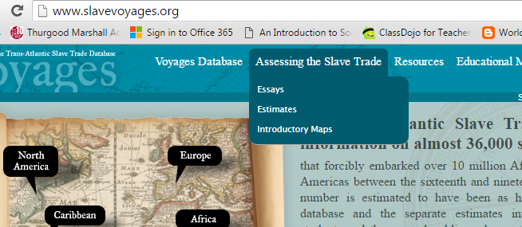

- Under the first tab “Tables” use the following criteria
  - Rows: 100 years
  - Columns: Flags
  - Cells: Embarked/Disembarked
This will show you the number of slaves that went on a ship (embarked) and went off a ship (disembarked) every 100 years for different countries.

Use the table on your screen to answer the following questions:
- Which country had the most slaves embark on its ships?

- Which country had the least slaves embark on its ships?

- How many slaves died before disembarking ships from Spain/Uruguay between 1801-1900?
(Hint! To do this, simply subtract the number of slaves that disembarked from the number that embarked)
Number that embarked: ____________
_{Minus}
Number that disembarked: _____________
_{Equals}
Number that died: _____________

- Select one of the European countries (Do NOT select Great Britain, U.S.A or Denmark.) You will be researching slavery in this country for the rest of the day today.
Country chosen: _____________________________________

- Using the template below, create a graph that shows the number of slaves that embarked and disembarked between 1500-1900.
An example has been provided.

Title: ___________________________________

1501-1600 1601-1700 1701-1800 1801-1900

Answer the following questions based off of the graph you created:
- In which years did the most slaves embark on slave ships?

- In which years did the most slaves die while on slave ships?

- What trend do you see happening to the number of slaves that embark on ships?

- What trend do you see happening to the number of slaves that die while on ships?

- Why do you think so many people died while on slave ships?

- Why did European traders allow so many people to die?

Part II
- Go to www.slavevoyages.org
- Under “Voyages Database” select “Search the Voyages Database”
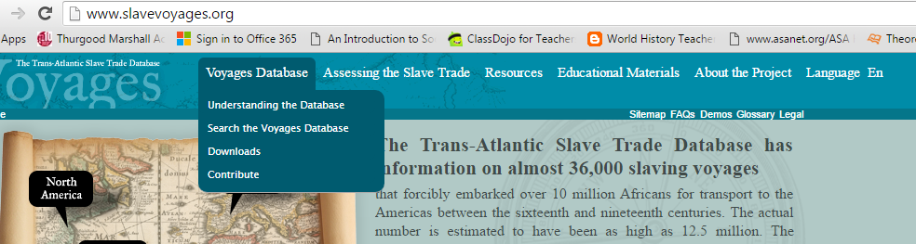

- On the left, select “Ship, nation, owners” and then select “voyage identification number”
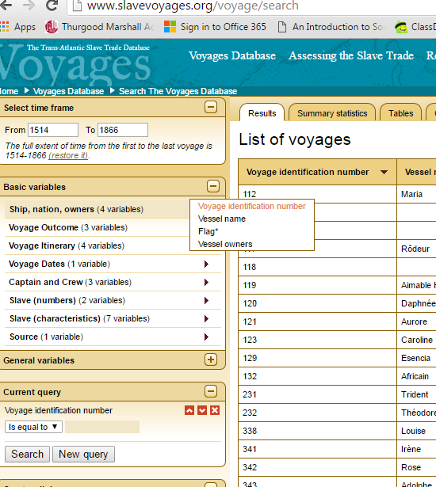
- Under “Current query” type in one of the following numbers, depending on the country you selected previously. Press “Search.”
Spain/Uruguay | Portugal/Brazil | Netherlands | France
2366  2315  1860  2358  2323  1367  2325  2324  2350 | 1569  2920  2328  2910  2912  5084  2898  2920 | 2758 | 34319

- Click on the voyage identification number in the center of the screen. You should be directed to a page that looks like this:
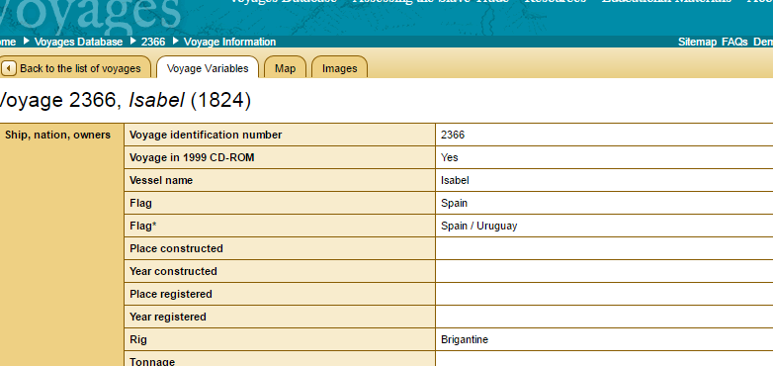

Voyage ID #
Flag
Vessel Name
First place of slave purchase
Outcome of voyage
Date Trade began in Africa
Date voyage completed
Captain Name
Total Slaves embarked
Total slaves disembarked
Percentage men
Percentage women
Percentage children
Slave deaths during middle passage
- Fill in the chart below using the information from the Voyage page. Some rows may be left blank if the database is missing information.

Answer the following questions based off the chart above:
Step III
- Go to www.slavevoyages.com
- At the top of the page, under “Resources” select “African Names Database”
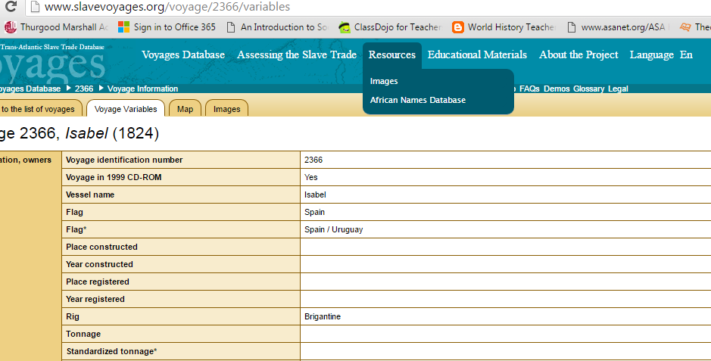
- On the left, type in your ship’s “Voyage ID” and hit enter on the keyboard
- You will see a list of names appear. Select one of the names on the list select “Go”
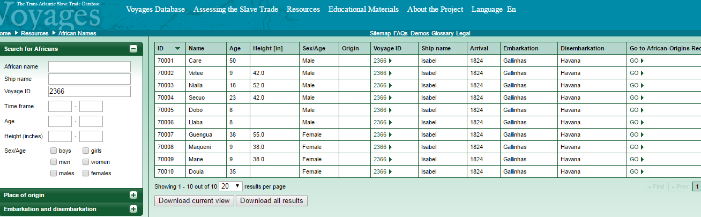
- Fill in the chart below. Some rows may be left blank if the database is missing information.
Name of slave
Gender
Age
Language/Ethnicity

Answer the questions below based on the slave you researched.

