Name_____________________________ Date__________ Unit 6: Triangular Trade
PACKET A
Do Now:
- Copy the objectives from the board:
-Students Will Be Able To: Describe the three parts of ______________________________________ and analyze the benefits and costs of trade on Africa, Europe, and the New World.

Today, we are starting a new unit on the Trans-Atlantic Slave Trade. Examine the map below and answer the questions that follow.
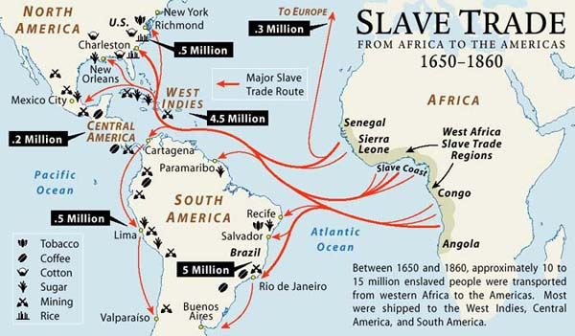

1. What areas of Africa were most slaves taken from?

2. What country received the most slaves?

3. How many slaves ended up in North America?

4. What types of goods were produced using slave labor?
The Transatlantic Slave Trade
What was the transatlantic slave trade?
- The transatlantic slave trade, was the____________________________________________ , and transportation of millions of Africans across the Atlantic ocean to North and South America from ___________________________________ A.D.
- How many Africans were enslaved?
  - Between _____________________________________ Africans arrived to North and South America as slaves between 1400-1900 A.D.
  - Millions _______________________________________________ died in Africa and when crossing the Atlantic ocean. This trip is called the _________________________________________________
  - Total number of Africans killed or enslaved between 1400-1900 A.D. 24 – 32 million
Map Questions
1. What part of Africa are the most slaves being taken from? ________________
2. Where are the most slaves ending up? ________________________
Who, Why, and How?
- European nations were responsible for the___________________________, enslavement, and ______________________________________ of Africans from 1400-1900 A.D.
  - Portugal and Britain transported the majority of African slaves to the __________________________________________ (North + South America)
- European’s enslaved Africans because they needed ______________________________________ to produce agricultural products (Sugar Cain, Tobacco, Cotton) in their North and South American colonies.
Who?
- Portugal accounted for _____________________________________________ trade from 1519 – 1700 A.D.
- __________________________________ ships carried 40% of all slaves from 1700-1800 A.D.
How?
- ____________________________________________________ members of opposing tribes\empires and marched their captives from the interior of Africa to the coast. ________________________________________________ in these forced marches.
- African empires_________________________________________________________________ , engaged in warfare and making slaves out of their defeated foes.
- Slaves were sold to Europeans for______________________________ , which resulted in more war and more slaves.
- Captives were taken to _______________________________________ on Africa’s western coast and sold to Europeans for guns, and goods (textiles, alcohol, horses etc.)
- Europeans built huge complex forts on the coast to ___________________________________________ thousands of slaves until ships could come to take them across the Atlantic
- Forts were built like____________________________________, designed to intimidate and confuse their chained inhabitants
STOP AND THINK
- Why did Africans sell slaves to the Europeans?

- Do you think they knew what the slaves would experience?

Triangular Trade
- The transatlantic slave trade became _______________________________________ and a triangular trade developed.
- Triangular Trade happens when a region had an export commodity that is not required in the region from which its major imports came
- In the first route, slaves were shipped to the Caribbean to create _________________________________ (Sugar, Tobacco, and Cotton)
- In the second route, these raw goods were shipped back to ___________________to be manufactured.
- In the third route, manufactured products such as guns, and textiles were shipped to Africa to buy slaves.
- The majority of Africans were taken to the ________________________________________________ (9.2 million) The Crossing of the Atlantic was called the “Middle Passage”

The Middle Passage
- The Middle Passage was the name for the _________________________________ slaves were taken from Africa to the Caribbean
- Africans were ___________________________________ and packed into crowded ships, many died of starvation and disease
- Slave ships were so interested in making money the crews would pack their cargo holes beyond capacity, _______________________________________________________________________
- Insurance policies were taken out against human “cargo.” These policies only could be collected if slaves drowned at sea. The __________________________________ who were sometimes thrown overboard so that the owners could collect.
Chattel Slavery
- Slavery has existed for_______________________________________________________.
- But the type of slavery as seen in the transatlantic slave trade, Chattel Slavery (the complete ownership of an individual as if they were not human but only property) was new and the combination of_______________________________________________________.
- From Equiano’s Narrative:
  - “ After fighting for a considerable time with great fury…our people obtained victory…those prisoners which were not sold or redeemed we kept as slaves: but how different was their condition from that of the slaves of the West Indies! With us they do no more work than other members of the community”
Triangular Trade Reading Answer Sheet

1. Why did Europeans colonists need slaves?

2. How was slavery in the Americas (chattel slavery) different from slavery in Africa?

3. What advantages did colonists see in enslaving Africans?

4. Why did many African rulers participate in the Atlantic slave trade?

5. Complete the blanks below:

a. ____________________ was transported from Europe to Africa.

b. ____________________ was transported from Africa to the Americas.

c. ____________________ was transported from the Americas to Europe.

6. Use the table to describe the positive and negative impacts of the slave trade on Africa, Europe, and the Americas. Leave the space blank if you think it does not apply.

 | Positive Impacts | Negative Impacts
Africa
Europe
Americas

Triangular Trade Poster
(50 points)
Using your notes and your answers to the reading questions, create a poster about the Triangular Trade. You must include everything in the list below on your poster. Cross off each item as you go to ensure you have included each aspect.

1. Label your map—use your reading map for guidance
- Europe
- Africa
- Americas
2. Draw 3 lines connecting the three areas in a triangle- Again, you can look to your reading map for guidance

3. Label each line and create a list of things that were transported on that part of the journey
- Middle Passage
- Colonial Products
- Manufactured Goods
4. Create images to go along with the items you listed as being traded during each section.

5. Write- On the back of your paper, write 1 paragraph to summarizes triangular trade. Be sure to include a description of each part of the trade route. Also explain which side of the triangle do you think benefited most from triangular trade? Europe? Africa? Or the Caribbean/New World? Explain why you think this side benefited most.

Exit Slip
1. List one thing that each of the three stops in triangular trade benefited from the exchange.

a. Americas:

b. Africa:

c. Europe:

2. Which stop was impacted the MOST by triangular trade? You may pick any stop, but most support your answer.

