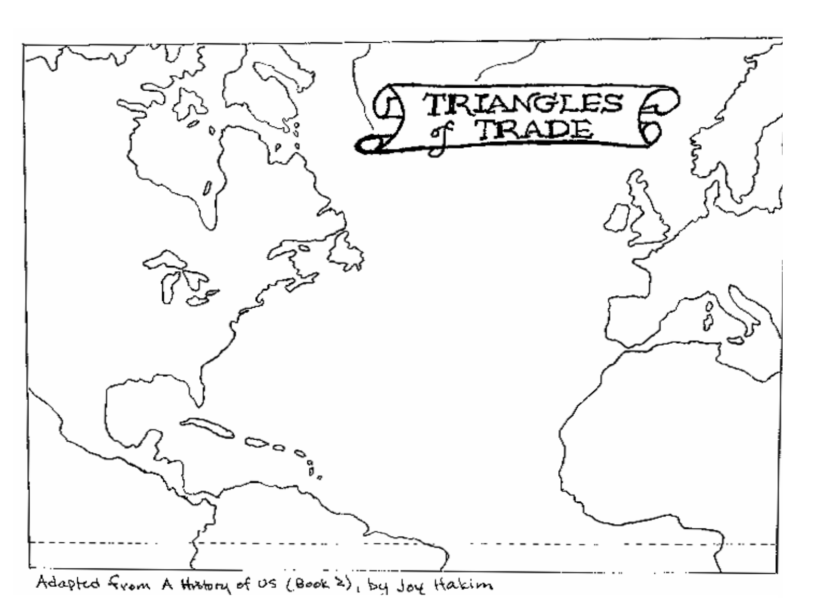
Name___________________________________ Date__________________
Write 1 paragraph that summarizes triangular trade. Be sure to include a description of each part of the trade route. Also explain which side of the triangle do you think benefited most from triangular trade? Europe? Africa? Or the Americas/New World? Explain why you think this side benefited most.
________________________________________________________________________________________________________________________________________________________________________________________________________________________________________________________________________________________________________________________________________________________________________________________________________________________________________________________________________________________________________________________________________________________________________________________________________________________________________________________________________________________________________________________________________________
________________________________________________________________________________________________________________________________________________________________________________________________________________________________________________________________________________________________________________________________________________________________________
________________________________________________________________________________________________________________________________________________________________________________________________________________________________________________________________________________________________________________________________________________________________________
________________________________________________________________________________________________________________________________________________________________________________________________________________________________________________________________________________________________________________________________________________________________________
________________________________________________________________________________________________________________________________________________________________________________________________________________________________________________________________________________________________________________________________________________________________________

