TMA PORTFOLIO PROJECT
2015-2016

Name: ______________________________
Due Date: __________________________
World History 1 Spring Portfolio Project
The Renaissance and Reformation DBQ
Historical Context: The Renaissance was a movement that began in the 1400s and lasted through the 1700s. The term Renaissance comes from the French work for rebirth. The movement began in Italy and spread to the rest of Europe. During this time many fields flourished such as literature, art, science, and religion.
Remember- Steps in writing a DBQ essay:
- Carefully read the task. Consider what you already know about the topic and make sure you understand what the task is asking you to know.
- Read each document carefully. Underline key phrases and words.
- Answer the questions that follow each document. These questions are there to help you break down and analyze important information about your document.
- Create a thesis that answers the task question.
- Write a well-organized essay about your thesis. Your essay should include support from the documents!
TASK: Write a well-developed, evidence supported 5 paragraph essay discussing the topic: Describe the rebirth that occurred during the Renaissance in art, science, and religion and how this rebirth showed growth from Medieval Times.

Due Dates:
Document Analysis Completed Due ___________
Rough Draft Completed Due ___________
Typed Draft Completed Due ___________
Final Essay Due ___________

Step 1- Document Analysis. This DBQ is slightly different from ones in the past. We have learned that the Renaissance was all about the idea of rebirth and development in all fields of life. In order to clearly show this you will be given sets of documents. In each set you will look at one document from Medieval Times and one document from the Renaissance.
Document 1 - The Church During Medieval Times | Document 2- The Church During the Renaissance
The Increasing Power of the Church  The Church also came to wield great political power. Latin, the language of the Church, was the only common language in Europe. Church officials were often the only people who could read. The church had great wealth and was known to be filled with expensive art.  The Selling of Indulgences  Starting in the 11th Century, the Medieval church began to use indulgences heavily. People were allowed to buy indulgences for the forgiveness of sins. Pope Urban even stated that those who went on the first Crusade would have enough indulgences to fully atone for their sins. Medieval people were very trusting of the church and also very superstitious. Thus, many people sent what little money they had ensuring their salvation. | Martin Luther’s 95 Theses were responsible for dividing the Catholic Church and sparking the Protestant Reformation. His teaching, that the Bible is the only religious authority (rather than the priests and Pope) and that salvation is reached through faith and not deeds, shaped the core of Protestantism. Below, you will find excerpts from Martin Luther’s 95 Theses (1517).  - The pope himself cannot remit* guilt, but only declare and confirm that it has been remitted by God; or, at most, he can remit it in cases reserved to his discretion. Except for these cases, the guilt remains untouched.  43. Christians should be taught that one who gives to the poor, or lends to the needy, does a better action than if he purchases indulgences  * remit- to forgive
1. What are two ways Document 1 shows the corruption of the Medieval Church? After you answer, underline a quote that best shows the wrongdoings of the Medieval Church.

2. What problems does Martin Luther’s 95 Theses point out? After you answer, underline a quote that best shows how the Protestant Church may have been improved from the Catholic Church.

3. How does Document 2 show a development or improvement in the church during the Renaissance? Answer using the quotes you underlined.

Document 3- A medieval Understanding of Medicine | Document 4- Da Vinci’s study of the human body
Excerpt from A History Of Western Medicine and Surgery  Records from doctor Usama ibn Munqidh 1175  "They brought to me a knight with a sore on his leg; and a woman who was feeble-minded. To the knight I applied a small pouch of herbs; and the woman I put her to rest in bed.  Then a French doctor came and said, "This man knows nothing about treating them." He then said, "Bring me a sharp axe." Then the doctor laid the leg of the knight on a block of wood and told a man to cut off the leg with the axe, upon which the marrow flowed out and the patient died on the spot.  He then examined the woman and said, "There is a devil in her head." He therefore took a razor, made a deep cross-shaped cut on her head, peeled away the skin until the bone of the skull was exposed, and rubbed it with salt. The woman also died instantly". | 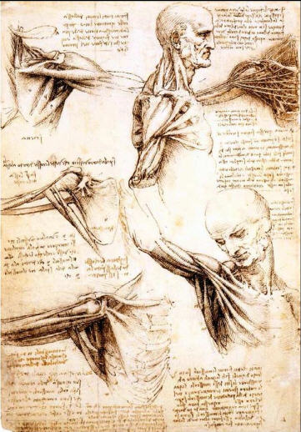  Leonardo concentrated on human anatomy more systematically than ever before – and by the end of his life he claimed that he had cut up more than 30 corpses. Leonardo compiled a series of 18 mostly double-sided sheets exploding with more than 240 individual drawings and over 13,000 words of notes. Leonardo made many important discoveries. For instance, he produced the first accurate illustration of the human spine. He was one of the first to document liver diseases.
4. What techniques did they use during medieval times to cure illness? After you answer the question, underline a quote that best shows their techniques.

5. What were some of Da Vinci’s discoveries on the human body? How did he make these discoveries? After you answer the questions, underline a quote that best shows Da Vinci’s methods.

6. How does Document 4 show a growth in knowledge of medicine from Document 3? Answer using the quotes you underlined.

Document 5- Medieval Art | Document 6- Renaissance Art
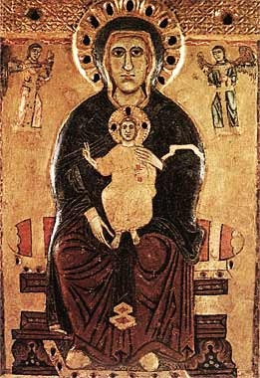  “Madonna of the Large Eyes” 1200 AD  A typical Madonna, it was made with dark outlines and simple geometric forms, and layered in gold so as to be easily seen within the candlelit cathedral. The artist did not try to make the figures look realistic, but depicted them as flat and without perspective. He also followed the tradition of using the size of figures to establish their importance. | 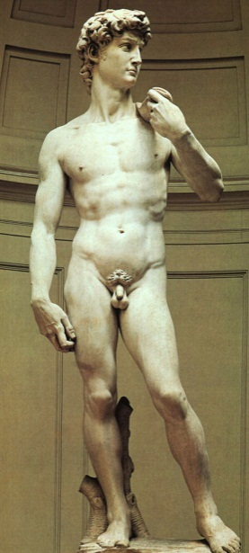  Michelangelo’s David created in 1501-1504 currently displayed at the Galleria Dell’Accademia, Florence
7. What elements of Medieval art are shown in Document 5?

8. Describe Document 6. What elements of Renaissance art are shown in the sculpture of David?

9. How does Document 6 represent a development in the understanding of the human body from Document 5? How does this relate to Humanism?

Document 7- Medieval Art | Document 8- Renaissance Art
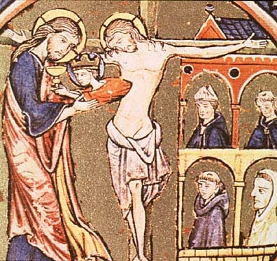  By Mozarabic Beatus, late 10th Century | 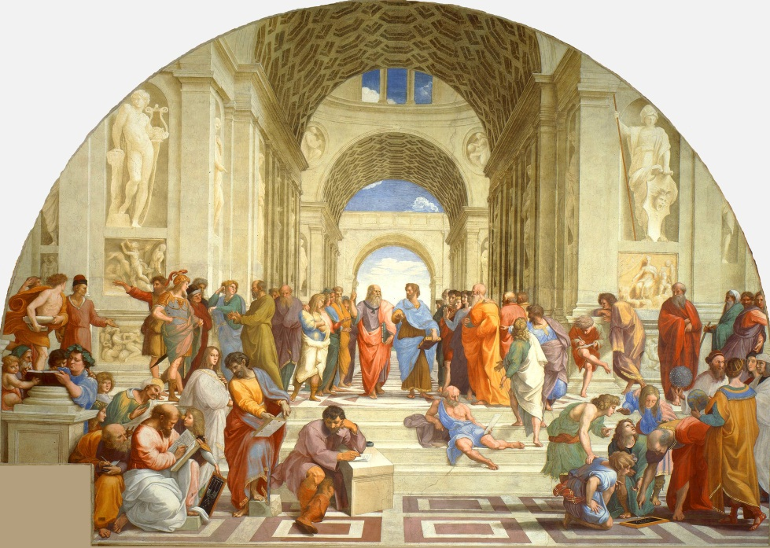  - The School of Athens 1509 by Raphael

10. What elements of Medieval art are shown in Document 7?

11. Describe Document 8. What elements of Renaissance art are shown in the painting?

12. How does Document 8 represent a development in art from Document 7?

Document 9- Excerpt from the Religious Writer St. Augustine During the Medieval Era | Document 10- Excerpts from Shakespeare’s Writings During the Renaissance
Great art Thou, O Lord, and greatly to be praised; great is Thy power, and Thy wisdom infinite. And Thee would man praise; man, but a particle of Thy creation; man, that bears about him his mortality, the witness of his sin, yet would man praise Thee; he, but a particle of Thy creation.  Saint Augustine Confessions, 1.1.1. 397-398 AD. | "What a piece of work is man! How noble in reason! How infinite in faculty*! In form and moving how express and admirable! In action how like an angel! In apprehension how like a god! The beauty of the world, the paragon* of animals!". - (Act II, Scene II of Hamlet)  *faculty- ability or ability to think  *paragon- the model of or perfect example of
13. Why does Augustine feel God is worthy of worship? How does he compare man to God? After you answer, underline a quote that best shows his view of man compared to God.

14. How does Shakespeare’s writing reflect the idea of Humanism? After you answer, underline a quote that best shows his view of man.

15. How does Shakespeare’s writing reflect a change in thought of religion and God from Medieval times to the Renaissance? Explain below using the quotes you underlined.

Document 11- Map of Europe during The Medieval Ear (1200 CE) | Document 12- Map of Europe after the Reformation (1530 CE)
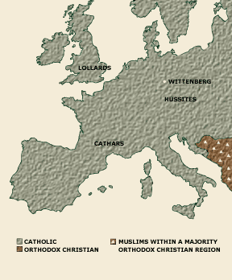 | 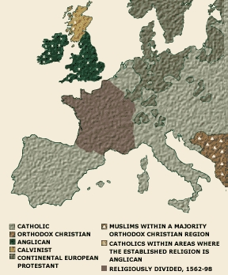
16. What religions are represented in Document 11?

17. How many more religions are represented in Document 12, after the Reformation?

18. How do these maps show the development that occurred during the Renaissance regarding religion?

Document 13- Medieval Views of the Universe | Document 14- Renaissance Views of the Universe
Ptolemy's model:  "Earth-centered," or "geocentric"  Ptolemy thought that all celestial objects — including the planets, Sun, Moon, and stars — orbited Earth. Earth, in the center of the universe, did not move at all.  NOTE: The outer planets, like Uranus and Neptune, are missing from both charts because they had not been discovered at the time.  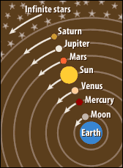  The church highly supported the Geocentric model of the universe as they believed the Bible stated the Earth was the center of the universe. The following are quotes from the Bible:  “Tremble before him, all the earth!  The world is firmly established; it cannot be moved.”  -1 Chronicles 16:30-  He set the earth on its foundations;  it can never be moved.  -Psalm 104:5-  The sun rises and the sun sets, then hurries around to rise again  -Ecclesiastes 1:5- | Copernicus’ model:  "Sun-centered," or "heliocentric"  Copernicus thought that the planets orbited the Sun, and that the Moon orbited Earth. The Sun, in the center of the universe, did not move, nor did the stars.  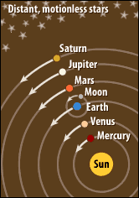  Copernicus was able to use newly improved telescopes to better study the skies. Even though he was wrong on some things, his view of the universe was a huge improvement.
19. Describe Ptolemy’s model of the universe, then underline a quote that best shows his model.

20. Describe Copernicus’s model of the universe, then underline a quote that best shows his model.

21. How do these documents show the rebirth of learning in science that occurred during the Renaissance? Explain below using the quotes you underlined.

Step 5: Create a Thesis
Remember the task question: Describe how the Renaissance showed growth from the Medieval Times through the rebirth in art, science, and religion.
List all the documents you want to use to help prove your thesis to be true. Remember- you should include evidence that proves the rebirth in all 3 categories.
Art Documents Science Documents Religion Documents

2. Draft a thesis: ____________________________________________________________________________
__________________________________________________________________________________________
__________________________________________________________________________________________

Step 6: Draft your essay
Introduction Paragraph- Check off each item below to make sure you write a well-structured paragraph
Review of Medieval Times- what was it? Why was it called the Dark Ages? | _______________________________________________________________________ _______________________________________________________________________ _______________________________________________________________________ _______________________________________________________________________ _______________________________________________________________________ _______________________________________________________________________
Definition of the Renaissance | _______________________________________________________________________ _______________________________________________________________________ _______________________________________________________________________
Time Frame | _______________________________________________________________________ _______________________________________________________________________ _______________________________________________________________________
Location | _______________________________________________________________________ _______________________________________________________________________ _______________________________________________________________________
Areas that Grew | _______________________________________________________________________ _______________________________________________________________________ _______________________________________________________________________ _______________________________________________________________________ _______________________________________________________________________ ______________________________________________________________________
How was the Renaissance a rebirth and improvement from the Dark Ages? | _______________________________________________________________________ _______________________________________________________________________ _______________________________________________________________________ ______________________________________________________________________
Thesis | _______________________________________________________________________ _______________________________________________________________________ _______________________________________________________________________ ______________________________________________________________________ ______________________________________________________________________
Body Paragraph 1- Check off each item below to make sure you write a well-structured paragraph
Point  - Topic Sentence (Reason 1 of thesis) | ___________________________________________________________________________________  _____________________________________________________________________________________________________________________________________________________________________.
Background Info  - What was it like during Medieval period? Renaissance period? | ___________________________________________________________________________________  ______________________________________________________________________________________________________________________________________________________________________________________________________________________________________________________________________________________________________________________________________________________________________________________________________________________________.
Evidence  - Quote Sandwich 1—Medieval  - Quote Sandwich 2—Renaissance  *An A paper will use two different documents to support each argument (which means it will include 4 quotes!) | ____________________________________________________________________________________________________________________________________________________________________________________________________________________________________________________________________________________________________________________________________________________________________________________________________________________________________________________________________________________________________________________________________________________________________________________________________________________________________________________________________________________________________________________________________________________________________________________________________________________________________________________________________________________________________________________________________________________________________________________________________________________________________________________________________________________________________________________________________________________________________________________
Explanation  How does your evidence support your thesis? How do your quotes show the growth from Medieval to Renaissance period? | ________________________________________________________________________________________________________________________________________________________________________________________________________________________________________________________________________________________________________________________________________________________________________________________________________________________________________________________________________
Body Paragraph 2- Check off each item below to make sure you write a well-structured paragraph
Point  - Topic Sentence (Reason 1 of thesis) | ___________________________________________________________________________________  _____________________________________________________________________________________________________________________________________________________________________.
Background Info  - What was it like during Medieval period? Renaissance period? | ___________________________________________________________________________________  ______________________________________________________________________________________________________________________________________________________________________________________________________________________________________________________________________________________________________________________________________________________________________________________________________________________________.
Evidence  - Quote Sandwich 1—Medieval  - Quote Sandwich 2—Renaissance  *An A paper will use two different documents to support each argument (which means it will include 4 quotes!) | ____________________________________________________________________________________________________________________________________________________________________________________________________________________________________________________________________________________________________________________________________________________________________________________________________________________________________________________________________________________________________________________________________________________________________________________________________________________________________________________________________________________________________________________________________________________________________________________________________________________________________________________________________________________________________________________________________________________________________________________________________________________________________________________________________________________________________________________________________________________________________________________
Explanation  How does your evidence support your thesis? How do your quotes show the growth from Medieval to Renaissance period? | ________________________________________________________________________________________________________________________________________________________________________________________________________________________________________________________________________________________________________________________________________________________________________________________________________________________________________________________________________
Body Paragraph 3- Check off each item below to make sure you write a well-structured paragraph
Point  - Topic Sentence (Reason 1 of thesis) | ___________________________________________________________________________________  _____________________________________________________________________________________________________________________________________________________________________.
Background Info  - What was it like during Medieval period? Renaissance period? | ___________________________________________________________________________________  ______________________________________________________________________________________________________________________________________________________________________________________________________________________________________________________________________________________________________________________________________________________________________________________________________________________________.
Evidence  - Quote Sandwich 1—Medieval  - Quote Sandwich 2—Renaissance  *An A paper will use two different documents to support each argument (which means it will include 4 quotes!) | ____________________________________________________________________________________________________________________________________________________________________________________________________________________________________________________________________________________________________________________________________________________________________________________________________________________________________________________________________________________________________________________________________________________________________________________________________________________________________________________________________________________________________________________________________________________________________________________________________________________________________________________________________________________________________________________________________________________________________________________________________________________________________________________________________________________________________________________________________________________________________________________
Explanation  How does your evidence support your thesis? How do your quotes show the growth from Medieval to Renaissance period? | ________________________________________________________________________________________________________________________________________________________________________________________________________________________________________________________________________________________________________________________________________________________________________________________________________________________________________________________________________
Paragraph 5: Conclusion
Restate Thesis—DO NOT COPY IT | ________________________________________________________________________________________________________________________________________________________________________________________________________________________________________________________________________________________________________
Summarize the three main points discussed in your paper—  - Sentence summarizing science  - Sentence summarizing art  - Sentence summarizing religion | ________________________________________________________________________________________________________________________________________________________________________________________________________________________________________________________________________________________________________________________________________________________________________________________________________________________________________________________________________________________________________________________________________________________________________________________________________________________________________________________________________________________________________________________________________________________________________________________________________________________________________________________________________________________________________________________
Final remarks—  - Why were the improvements important for the people during that time?  - How did these improvement shape our world today? | ____________________________________________________________________________________________________________________________________________________________________________________________________________________________________________________________________________________________________________________________________________________________________________________________________________________________________________________________________________________________________________________________________________________________________________________________________________________________________________________________________________________________________________________________________________________________________________________________________________________________________________________________________________________________________________________________________________________________________________________________________________________________________________________________________________

WORLD HISTORY
Name: ______________________________
SPRING PORTFOLIO PROJECT
Renaissance/Reformation DBQ
 | Exceeds Expectations | Meets Expectations | Below Expectations | Does Not Meet
Part 1  Analysis of Documents  (25 points) | Inclusion of Evidence:  Justifies claims using specific, detailed and varied evidence from a variety of reliable sources.  10-9 points | Inclusion of Evidence:  Justifies claims using appropriate specific evidence from a variety of reliable sources.  8-6 points | Inclusion of Evidence: Attempt to justify claim using some appropriate evidence. Majority of evidence used is indirect, and only partially supports claim.  5-3 points | Inclusion of Evidence:  Justifies claims using generalizations or limited appropriate direct evidence.  0 points
 | Interpretation:  Correctly identifies the type historical source;  Applies prior and new knowledge to determine the validity and correctly interprets the source to support claim.  15 pts. | Interpretation:  Correctly identifies the type historical source;  Applies new knowledge to determine the validity and correctly interprets the source to support claim.  13 -11 pts. | Interpretation:  Attempts to identify the type historical source;  Applies limited knowledge to determine the validity and correctly interprets the source to support claim.  7 pts. | Interpretation:  Attempts to determine the historical setting of sources without fully understanding the historical context OR does not correctly interpret the source to support the claim.  0 pts.
Part II  Thesis/ Introduction  (10 pts.) | Thesis statement is well-developed, original and makes an argument. Also includes three supporting details  Background information is included with sufficient detail  15 pts. | Thesis is only partially developed. Supporting details are included  Background information is included.  13 -11 pts. | Thesis is poorly developed and missing supporting details  Background information is missing.  7 pts. | Missing  0 pts.
Part III  Body Paragraph One  (10 pts.) | Student includes a topic sentence, includes excellent evidence from the documents, and thoroughly explains the evidence given.  10 pts. | Student includes a topic sentence, has evidence from the documents, but does not fully explain the evidence given.  8.5 or 7.5 pts. | Student has a vague topic sentence, no official reference to documents, and no explanation of evidence.  4-6 pts. | Missing  0 pts.
Part IV  Body Paragraph Two  (10 pts.) | Student includes a topic sentence, includes excellent evidence from the documents, and thoroughly explains the evidence given.  10 pts. | Student includes a topic sentence, has evidence from the documents, but does not fully explain the evidence given.  8.5 or 7.5 pts. | Student has a vague topic sentence, no official reference to documents, and no explanation of evidence.  4-6 pts. | Missing  0 pts.
Part V  Body Paragraph Three  (10 pts.) | Student includes a topic sentence, includes excellent evidence from the documents, and thoroughly explains the evidence given.  10 pts. | Student includes a topic sentence, has evidence from the documents, but does not fully explain the evidence given.  8.5 or 7.5 pts. | Student has a vague topic sentence, no official reference to documents, and no explanation of evidence.  4-6 pts. | Missing  0 pts.
Part VII  Conclusion (10 points)  (9.W-E.5) | The Essay has a brief conclusion that summarizes the three reasons described in the body. Includes a sentence that restates or re-emphasizes the thesis. 10 pts | Essay has a brief conclusion that re-emphasizes and summarizes the thesis and three main points described.  8.5 or 7.5 pts | Essay has a weak and incomplete conclusion that does not re-state thesis or summarize the three main points described.  4-6 pts | Missing 0pts
Part VI  Spelling, grammar, proofreading, and formation  (15 pts.) | Proper Heading ( ____ 2 pts) No personal pro-nouns (____ 2 pts)  Double Spaced (____ 2 pts) Proper Spacing between paragraphs (_____ 2 pts)  Grammar Errors:  1-3 Errors (_____ 7 pts) 4-6 Errors (______ 5 pts) 7-10 Errors (_____ 3 pts)  More than 10 ( ____ 0 pts)
Part VII  Citations  (10 pts) | Citations are included in MLA format, all necessary information is cited  10 pts | Citations are mostly accurate; a few inconsistencies or errors in information  8.5 or 7.5 pts | Completely inaccurate; the format was not MLA  4-6 pts | Citations are missing  0 pts

TOTAL ___________________/100
Scale: 100-97=A+ 96-93= A 92-90=A- 89-87=B+ 86-83=B 82-80= B- 79-77=C+ 76-73= C 72-70= C- 69 and below= F

Comments:

