Name_____________________________ Date__________ Unit 6: Renaissance and Reformation
PACKET D
Do Now:
- Copy the objectives from the board:
-Students Will Be Able To: Analyze the effects of the Protestant Reformation on the _______________, __________________________ and the Catholic Church and explain the motivation for Henry VIII’s break from the Catholic Church.

- Chart Completion: Fill in the Chart below
 | Definition in your own words | Important Person | How it changed life from before the Renaissance
Humanism
Renaissance
Reformation

Effects of the Protestant Reformation
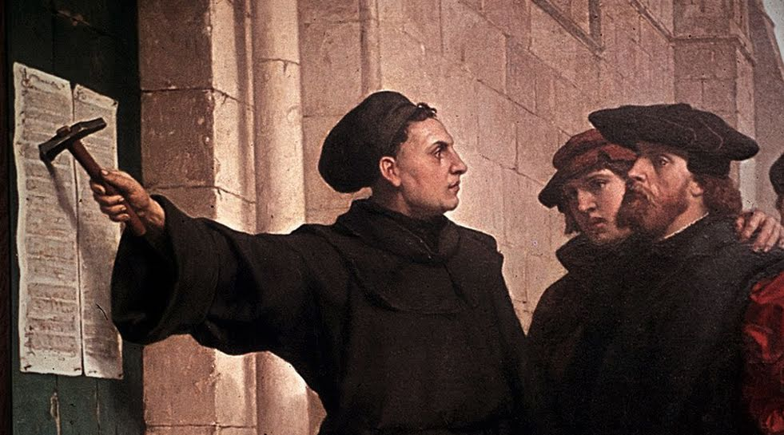
Women and the Poor during the Reformation
The Protestant Reformation elevated the status of women in several ways. It emphasized the importance of marriage and the role of woman in the Christian home. Rather than the Church as the center of life, Protestantism instead emphasized the family. Because of this, Protestantism abolished convents (places where nuns lived) and allowed its ministers to marry. Furthermore, it encouraged the education of girls as the future teacher and nurturer in the home as wife and mother. In other words, it was important for girls to be educated so that they could grow up to teach their sons.

The poor were influenced by Protestant writings as well. Luther preached that Christians and European states need large economic reforms. He believed that the poor were being treated unfairly and should not give up so much of their little money for the Church.

1. How did Protestant ideas affect women?

2. How did Protestant ideas affect the poor?

3. Do you think it was more beneficial for women to adopt Protestant beliefs or remain with the Catholic Church?

Impact on Literacy
The Protestant Reformers encouraged their followers to become literate in order to read the Bible for themselves. Martin Luther and many others translated the Bible into the languages of their country. This encouraged a desire amongst regular people to learn to read in order to develop a personal understanding of the Bible. The invention of the Printing Press around this time also allowed for the quick spread of the newly translated Bible as well as the ideas of Luther and other reformers of the time.

4. Why did Protestantism encourage literacy (the ability to read)?

5. How did the invention of the printing press affect literacy?

The Catholic Church’s Response: The Counter Reformation
The Catholic Church underestimated the impact of the Reformation at first, considering it just another problem of the Church. Soon, however, they saw the movement spreading from one country to another.
The church took action. From 1545 to 1563 the Council of Trent issued orders to correct the new ideas people were exploring and to return to traditions of the Church. They created an Inquisition, or an institution whose purpose it was to find and get rid of heretics (people against the Catholic Church). Protestants were imprisoned, tortured, and punished in various ways. Catholic missionaries also spread across the globe to try to convert native peoples to Catholicism.
By the close of the 16th century the Roman Catholic Church had regained the faith of the people in half of the lands it had lost to the Protestants. Europe was then divided between the two groups of Christianity along almost the same lines that exist today.
6. What action did the church take to stop the reformation?

7. Was it successful?

Henry VIII Biography

A Brief Introduction to Henry the VIII
Henry VIII ruled England from 1509-1547 and remains one of that country's most famous and controversial kings. Henry's huge appetite and strange passions are legendary, and his demand for a male son to lead his kingdom led him to marry six different women. (Two of those wives, Anne Boleyn and Katharine Howard, were beheaded on his order.) Henry's divorce from his first wife, Catherine of Aragon, led the king to split with the Catholic Church and found his own church, the Church of England, which in turn set the stage for the English Reformation and for religious battles which lasted for centuries. Henry is also known for his weight problems due to his lavish appetite; his obesity probably contributed to his death at age 56.
Henry’s Many Wives
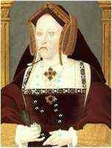
Why did Henry have so many wives? The usual answer was that he wanted a son to be his heir. But actually he had plenty of sons, sadly most of them died but one survived, born to his third wife. So why did he have another three wives after that? Although he had one son, children died very easily in Tudor times, so he really needed a second one to make sure. Plus maybe he just fell in love easily and he was extremely spoiled and used to having whatever he wanted. He wouldn't let anything stand in his way.

1- Catherine of Aragon First she married Arthur, Henry's older brother. But after six months, he died, and Catherine was engaged to Henry instead. She was 17 and Henry was only 12! They were married when he became King in 1509. She was older and wiser than him and often gave him advice on how to rule. She was a good and faithful wife for over twenty years. She had many children, but only one survived, Mary, who would later become Queen.
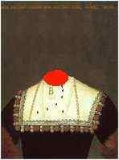
2- Anne Boleyn Henry fell in love with Anne when she was a servant in the Queens Household in 1522. By 1526 he was trying to get divorced from Catherine so that he could marry her. The head of the Catholic church, the Pope, wouldn't allow it, so eventually Henry broke away from the church in Rome, and declared himself the head of a new Church of England. He granted himself a divorce. He married Anne in 1533, and later that year she gave birth to a girl, Elizabeth who would grow up to be a strong Queen for England. Henry soon got fed up with Anne, (apparently she was really grumpy!) so he accused her of meeting other men. There is a letter from Anne begging Henry to believe in her innocence but he didn't and in 1536 she was beheaded. Henry played tennis whilst she had her head chopped off! 11 days later Henry married this third wife.

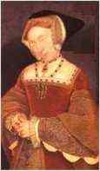
3- Jane Seymour Jane was from an old and noble family. She was gentle and modest and not grumpy like Anne. She gave birth to a son in 1537, Edward, who would become King after his father. Sadly 12 days later she died. It is said that Henry loved Jane the best of all his wives and he waited two years before marrying again.

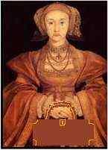
4- Anne of Cleves Henry wanted to make a 'good' marriage this time and decided to look all over Europe for a bride. He sent painters to paint any eligible brides so he could see what they looked like. A picture was shown to him of Anne of Cleves and he agreed to marry her without ever having met her! When she arrived in England, Henry was very excited to meet her but she didn't speak any English and didn't know who he was. She was rather rude to the fat man that came to see her (Henry) and ignored him. Henry stormed out shouting 'I like her not!' He is said to have found her repulsively ugly, and called her a horse! He couldn't break his promise to marry her but it only lasted six months. 20 days after his second divorce, Henry married his fifth wife.
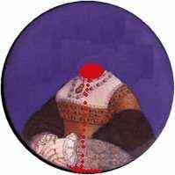
5- Katherine Howard Katherine was a cousin of Anne Boleyn and was only about 16 when she came to court. No-one knows her actual birthdate, but she was still a teenager when they married. (He was 49!) She was lively, pretty, kind and a bit of a 'bird brain' but Henry thought she was perfect. However she was previously, secretly engaged to one man and possibly a second one too. When the King found out he chopped both the men's heads off, followed by Katherine's head in 1542. The following year he married for the last time.
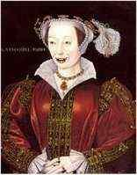
6- Kathryn Parr Kathryn had already been married twice before, but both her husbands had died. She was really in love with Thomas Seymour (Jane Seymour's brother) but she was too scared to refuse the King (which was probably wise with his reputation for chopping off women’s heads!). Henry was very, very fat and ill by now and Kathryn was as much a nurse as a wife. She was a kind woman and was the first wife to bring all three of his children to live together under one roof. When Henry died in 1547, Kathryn quickly married Thomas Seymour.

Match the wife to the statement- You will use some wives more than once
1. I am the wife who was so unattractive that Henry divorced me after 6 months _____________________
2. Henry agreed to marry me without ever having met me in person ____________________________
3. I was married to Henry’s brother before I married him _______________________________
4. Henry was very fat when I married him so I became his nurse _______________________________
5. Henry fell in love with me and divorced his wife to marry me ___________________________
6. I was the wife that Henry loved the most ___________________________
7. I was beheaded because Henry got fed up with me ________________________
8. I was beheaded because Henry found out I had been secretly engaged twice before ____________________
9. Henry married me only 20 days after divorced his 4th wife _______________________
10. I died giving birth to Henry’s only son _________________________
11. Henry broke away from the church to marry me _______________________
12. Henry was so fat when he became my husband that I ignored him ________________________

Video Guide- As you view the film- Answer the questions that follow
http://www.youtube.com/watch?v=1xW7BhEBeEA
1. What job was Henry being prepared for when he was younger? Describe his training in a few sentences.

2. Who was Kathryn first married to?

3. What did the bible say about marrying your brother’s wife? How is this a prediction to the future for Henry?

4. Describe Henry’s looks when he marries Kathryn.

5. What other country did Henry want to invade?
a. Spain
b. France
c. Italy
6. What weapon was Henry fond of using? ________________________

7. What was Kathryn’s failure?

8. What do you think- Did Henry like Anne because he was seduced by her or was he so upset over Kathryn not being able to have a son?

9. Describe how Henry tries to get out of his marriage.

10. True or False: Anne convinced the King that he was more powerful than the Pope and therefore didn’t have to listen to his ideas. _______________

11. Which wife gave Henry his first male son? _________________________

12. Who did Henry blame for his unhappy marriage to Anne of Cleaves? What was the punishment?

13. Describe how Henry’s health and physical appearance changed throughout his life.

14. Why did Henry have to be hoisted up by many men onto his horse?

15. Describe the sad decline of the end of Henry’s life.

Exit Slip

What should history say about Henry the 8th? One view is that Henry the 8th was insane and crazed. The other view is that Henry was simply trying to protect his kingdom by providing it with a male heir.
Fill in the chart below with evidence for both sides- You need at least 3 reasons for each side
He was INSANE! | He was a strong leader that wanted to provide for his kingdom

