Middle Passage Primary and Secondary Sources

Source 1: On being captured
“One day, when all our people were gone out to their works as usual, and only I and my dear sister were left to [take care of] the house, two men and a woman got over our walls, and in a moment seized us both, and, without giving us time to cry out, or make resistance, they stopped¹ our mouths, and ran off with us into the nearest wood. Here they tied our hands, and continued to carry us as far as they could.”
Source: http://www.historytools.org/sources/equiano.pdf

¹covered

Source 2: Communication

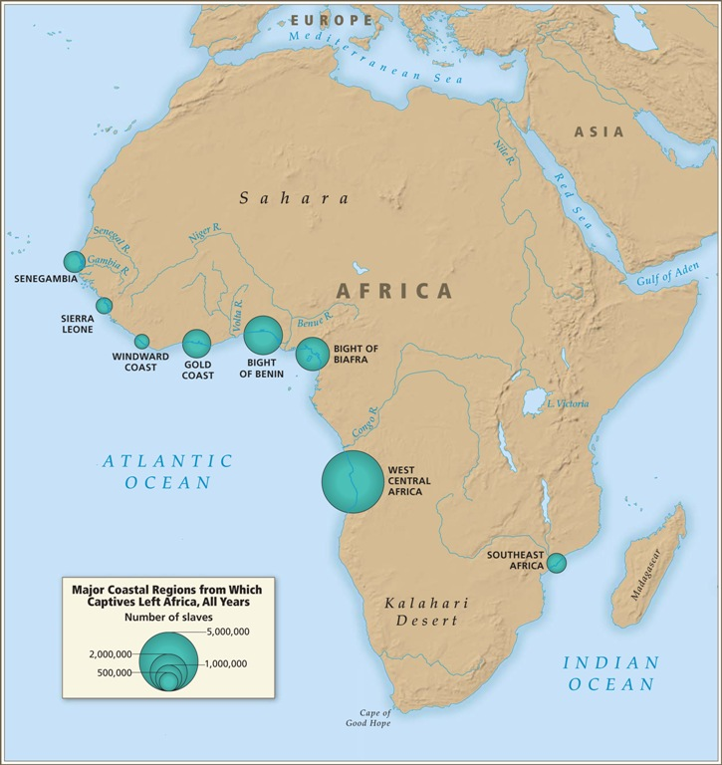
Communication between slaves on the Middle Passage was limited. Often, the fellow prisoners came from different regions that spoke different languages. Therefore, they could not even turn to one another for comfort or companionship. The prisoners were virtually alone in a scary, unknown world awaiting an unknown future. They had been taken from their families, homes and knew nothing of why or where they were going.

Source 3: Emotions of slaves
“On being brought on board, the slaves show signs of extreme distress and despair, from a feeling of their situation, and regret at being torn from their friends and connections. Many retain those impressions¹ for a long time. On one ship, the slaves on board were often heard in the night, making a howling melancholy² noise, expressive of extreme anguish³. The interpreter discovered the noise to be owing to their having dreamt that they were in their own country again, and finding themselves when awake, in the hold of a slave ship.”
Source: An Abstract of the evidence delivered before a select committee of the House of Commons in the years 1790-1791, on the part of the abolition of the slave trade

1. feel that way
2. depressed
3. sorrow, pain, distress

Source 4: Shackles
“The men negroes, on being brought aboard ship, are immediately fastened together two and two, by handcuffs on their wrists, and by irons riveted¹ on their legs…They are frequently stowed² so close as to admit of no other posture than lying on their sides. Neither will the height between decks, unless directly under the grating, permit them the indulgence of an erect posture³…”

“It often happens that those who are placed at a distance from the buckets⁴, in endeavoring to get to them, tumble over their companions, in consequence of being shackled. These accidents, though unavoidable, are productive of continual quarrels, in which some of them are always bruised. In this distressed situation they desist from the attempt, and this becomes a fresh source of broils and disturbances, and tends to render the situation of the poor captive wretches still more uncomfortable”

1. Used as toilets
2. attached to
3. kept
4. standing position
Source: From the African Slave-Trade and its Remedy

Source 5: Meals
“In favorable weather slaves are fed upon the deck of the ship, but in bad weather their food is given to them below. Numberless quarrels¹ take place among them during their meals; more especially when they are put upon short allowance², which frequently happens. In that case, the weak must be content with a very small portion. The allowance of water is about half a pint each, at every meal.”
Source: From the African Slave-Trade and its Remedy

1. fights
2. given small portions

“These meals consist of rice, yams, and horse-beans, with now and then a little beef and bread”
Source: An Abstract of the evidence delivered before a select committee of the House of Commons in the years 1790-1791, on the part of the abolition of the slave trade

“Upon the negroes refusing to take food, I have seen coals of fire, glowing hot, put on a shovel, and placed so near their lips as to scorch and burn them, and this has been accompanied with threats of forcing them to swallow the coals, if they any longer persisted in refusing to eat. These means have generally the desired effect. I have also been informed that a certain captain in the Slave Trade poured melted lead on the negroes that refused their food. Negroes are sometimes compelled to dance and to sing. If any reluctance is exhibited, the whip is employed to enforce obedience.”
Source: From the African Slave-Trade and its Remedy

Source 6: Treatment of Women
“On board some ships the common sailors are allowed to have intercourse with the black women whose consent they can procure¹. And some of [the women] have been known to [feel so horrible about the intercourse] as to leap overboard and drown themselves. The officers are permitted to indulge their passions among them at pleasure and sometimes are guilty of such excesses as disgrace human nature²…”
http://www.learnnc.org/lp/editions/nchist-colonial/1904

1. obtain, get
2. The sailors would often rape the female slaves

Source 7: Fresh Air
“The exclusion of fresh air is among the most intolerable [aspects of life]. In order to provide some air, most of the ships in the slave trade have, between the decks, five or six air-ports on each side of the ship, of about five inches in length and four in breadth…. But whenever the sea is rough, and the rain heavy, it becomes necessary to shut these. The fresh air being thus excluded¹, the Negroes' rooms soon grow intolerably hot. The confined air, rendered noxious² and being repeatedly breathed, soon produces fevers and the flu which generally carries off³ great numbers of them.”
Source: http://www.pbs.org/wgbh/aia/part1/1h281t.html

1. Without fresh air
2. poisonous
3. kills

Source 8: Illness
“The floor of their rooms was so covered with the blood and mucus, [which came] from them in consequence of the flu, that it resembled a slaughter-house. It is not in the power of the human imagination to picture a situation more dreadful or disgusting. Numbers of the slaves having fainted, they were carried upon deck where several of them died and the rest with great difficulty were restored.”
Source: http://www.pbs.org/wgbh/aia/part1/1h281t.html

In this manner we continued to undergo more hardships than I can now relate, hardships which are inseparable from this cursed trade. Many a time we were near suffocation from the want of fresh air, which we were often without for whole days together. This, and the stench of the necessary tubs¹, carried off many…”
Source: http://www.historytools.org/sources/equiano.pdf

1. buckets used as toilets

Source 9: Being Sold
“We were conducted¹ immediately to the merchant’s yard, where we were all pent up together like so many sheep in a fold, without regard to sex or age. . .
We were not many days in the merchant’s custody before we were sold after their usual manner, which is this: On a signal given, (as the beat of a drum) the buyers rush at once into the yard where the slaves are confined², and make choice of that parcel they like best. The noise and clamor with which this is attended, and the eagerness visible in the face of the buyers, increase the apprehensions³ of the terrified Africans, who may well be supposed to consider them as the ministers of that destruction to which they think themselves devoted⁴. In this manner, relations and friends are separated, most of them never to see each other again”
Source: http://www.historytools.org/sources/equiano.pdf

1. taken
2. held
3. worries
4. slaves are terrified of the buyers, who will become their masters

