Name________________________Date_________ Unit 3: Mesoamerica
Total Points: ________
PACKET C
Do Now:
- Copy the objectives from the board:

Students Will Be Able To:

-Describe the _________________________________________________ of the conquistadors on the Aztec and Incan civilization as well as conquistador perception of the Aztecs through guided notes, a graphic organizer, and the first DBQ document.

- Chart analysis

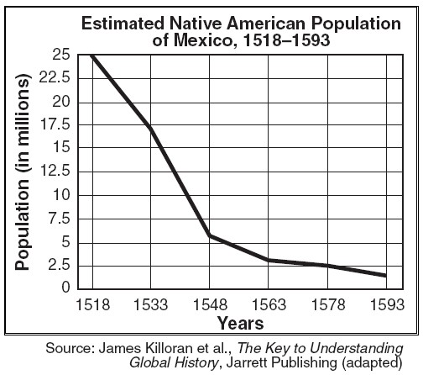
1. What trend do you see happening to the Native America population over time?

2. About how many people did the Native American population loose between 1548 and 1578?

3. Why do you think this change in population happened? What could have caused this change? Make some predications.

New World Encounters: Fall of the Mesoamerican Civilizations
Mesoamerica Notes 3
The Age of Exploration
- As methods of ___________________________ increased, people started to wonder what ___________________________________________ their countries
- In 1492 __________________ was the first explorer to set out in hopes of reaching _________________________
- He sparked a series of explorers who wanted to make a name for themselves as he had
- These new travelers became known as____________________________
God, Glory, Gold
- There were 3 main draws for explorers:
  - ______________- Explorers hoped to gain fame and make a name for themselves and their countries
  - ______________- Explorers wanted to spread the religion of Christianity
  - ______________- Explorers wanted to grow wealthy from their travels and find new sources of income in the new lands

Cortes and the Aztecs
- Cortes was one of the first Spanish conquistadors
- In 1519 he arrived in Mexico with ________________________________________ , and a few cannons
- He headed for Tenochtitlan- the ____________________________________________________________
- Along his way Cortes met _____________________ , she was a young Indian woman who became his translator and helped him gain allies with other Indian groups
- Moctezuma was the leader of the Aztecs and thought that Cortes _________________________________________________ of old prophecies
- Moctezuma ______________________________ Cortes into the city but fighting still broke out due to Cortes’s _________________________________________________________ of Tenochitilan
- The Aztec city was destroyed and soon after most of the Aztecs _________________________
- An unknown Aztec was quoted as saying “Broken spears lay in the road, We have torn out our hair with grief, The houses are roofless now and their walls are red with blood.”

Stop and Think
- How do the images show the change in the relationship between the Aztecs and conquistadors?
______________________________________________________________________________
______________________________________________________________________________
Pizarro and the Incas
- Inspired by Cortes’s success, ______________________________ arrived in Peru in 1532
- By _____________________________, Pizarro captured the leader of the Incas, Atahualpa
- Even after the Incas paid the ransom Pizarro had requested to set Atahualpa free________________________________________________
- Pizarro ___________________________________ the Incas

Reasons for Conquistador Success
- 1- Disease- Europeans introduced many ____________________________________ to the Americas that killed thousands of Indians
- 2- Weapons- Europeans had ___________________ that frightened the Indians they also had ____________________ and more advanced _________________ such as metal which protected the Europeans
- 3- Internal fighting between Indian groups- The Europeans played upon the ___________________________________________________________ and turned them against one another
- 4- Religious beliefs of Indians- Some Indian prophecies foretold the ___________________________ and many Indians believed that is what the Europeans signified

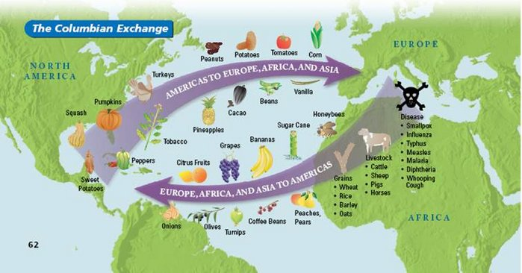
Stop and Think

- What would be some positive and negatives effects of the Columbian Exchange?
______________________________________________________________________________________________
______________________________________________________________________________________________
- What side do you think benefited more? Europe or the New World?
______________________________________________________________________________________________
_____________________________________________________________________________________________

DBQ Document 1 Questions
Cortes’s Letter to the King of Spain on Tenochtitlan
4. and 5.
3.
2.
1.

Meaning
Cortes’s Words

8.

7.
6.

Exit Slip
The Conquistadors were successful for 4 reasons. Fill in the chart with these four reasons below. Then, explain how these led to the decline of the Native Americans.
Of these four reasons, which had the biggest effect on the decline of Native American civilizations?

