Name_____________________________ Date____________ Unit 5: Medieval Europe

PACKET AA

Do Now:

1. **Copy the objectives from the board:**

-Students Will Be Able To: Describe Feudalism in Medieval Europe and provide evidence to prove that life in Medieval Europe was difficult, ____________________, and unfair through guided notes, reading questions, and a short writing prompt.

1. **What do you already know?**

Our new unit will cover Medieval Europe. Write down any terms, images, people, etc. that come to mind when you hear the word MEDIEVAL or Dark Ages.

1. **Image Reflection**

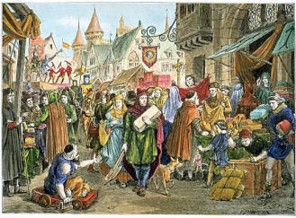 **Examine the images. What do you see? Describe what you think is happening in the images.**

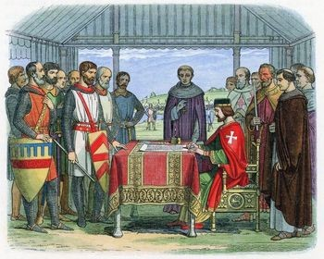

j0237940

**Medieval Scavenger Hunt**

**You travel in time to a Medieval Kingdom. You have never been here before and you are excited to meet as many different people as you can. Try to find a person who fits each of the following descriptions:**

1. Someone who works all day as a farmer to serve his lord: _____________.
2. The head of the Roman Catholic Church: _________________________.
3. The lowest ranked of the lords: ________________________________.
4. A woman who has taken a vow of chastity and loyalty to the Church: _____.
5. A man who is responsible for preserving ancient texts by recopying them carefully by hand: ______________.
6. A man trained in the art of battle to defend his lords and king: _________.
7. A monk or nun who travels to convert others to Christianity: ___________.
8. Someone who, by law, may not leave their land: ___________________.
9. Someone who is often persecuted by Christians: __________________.
10. The person directly under the pope in the Church: ___________________.
11. A person who must divide his land (estate) into fiefs (smaller pieces of land) to give to the lesser lords: ______________________________.
12. Someone who often fights with the pope over who has the most power: ______________.
13. Someone who leads the local Church in prayer, guides the people in their spiritual lives, and helps them in troubled times: _________________.
14. A man of the Church who is below the archbishop but above the priest: ________________.
15. A woman, also known as “lady” of the house, who must manage the estate when her husband is away serving his lord in battle: ______________

**Europe in Medieval Times Notes 1**

**Medieval Times**

* As Roman Civilization declined, Europe became an_______________________________________________ , conflict and poverty.
* People no longer had the Roman Empire to _______________________________________________ them
* Between 400 and 700, Germanic tribes carved Western Europe into small kingdoms.
* This signaled the beginning of the _____________________________

**Map of Europe**

How did Europe change after the fall of Rome? **___________________________________________ _________________________________________________________________________________________**

**Feudalism**

* In Medieval Times, people lived difficult lives
* It took a lot of work to __________________________
* A political system called ________________________________ was created to solve these issues

**Stop and Think**

Imagine a time before you could go to the store on the corner to buy the things you need to live. What types of activities would people in Medieval times need to do for themselves in order to be able to survive? **__________________________________________**

**___________________________________________________________________________________**

**___________________________________________________________________________________**

* Feudalism is:
  + A system where people ______________________________ to a lord or powerful land holder and in return ____________________________ and protection
* In Feudal society, people had _________________________ that they played
* At the top was the King
* Underneath the King were his ________________ who he gave land to
* Nobles allowed knights, _____________________ , and serfs to live on their land in exchange for their ______________________ to the Noble
* During the Middle Ages, people were born into a ___________________________________.

They had the same social position, and often the same job, as their parents.

**CHECK FOR UNDERSTANDING**

**King**

**Directions:**

In the downward pointing arrows on the diagram, write an example of what each level of feudal society gave to the level below it. In the upward pointing arrows, write an example of what each level gave to the level above it.

**Nobles**

**Peasants**

**Roles in Medieval Society**

* The feudal system made sure each person played a ____________________ for society to function.
* Without any one person in the system, the society would fail
  + King: The ______________________ and the one who was in charge of making decisions
  + _______________________________ - The noble men, or wealthy land owners who were given manors from the King. The Ladies were their wives and daughters
  + Knights- the ____________________________ of the King and Lords
  + Peasants- _________________________________________
  + Serfs- Peasants who ________________________ to leave the land

**Stop and Think**

1. What other country did we learn about that had a feudal system? _______________________

2. How was that system alike or different than the one in Europe? __________________________ **____________________________________________________________________________________________________________________________________________________________________________________**

**Life in Medieval Europe**

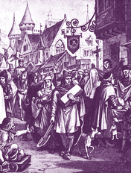At the start of the Middle Ages, most people lived in the countryside, either on feudal manors or in religious communities. But by the 12th century, towns were growing up around castles and monasteries (buildings where monks live) and along trade routes. These bustling towns became centers of trade and industry.

Almost all medieval towns were protected by thick stone walls. Visitors entered through gates. Inside, homes and businesses lined unpaved streets. Since few people could read, signs with colorful pictures hung over the doorways of shops and businesses. Open squares in front of public buildings, such as churches, served as gathering places.

Most streets were very narrow. The second stories of houses jutted out, blocking the sunlight from reaching the street. Squares and streets were crowded with people, horses, and carts—as well as cats, dogs, geese, and chickens. There was no garbage collection, so residents threw their garbage into nearby canals and ditches or simply out the window. In the houses, there was no in-door plumbing or hot water, so people rarely bathed. Trash was thrown onto the floor before tossed, which led to insects, rats, and odor. All these issues led to frequent disease.

1. Describe what a medieval town would have looked like.

2. Name two things that would have caused the town to have a bad odor.

3. Name two things that caused disease.

**Homes and Households**

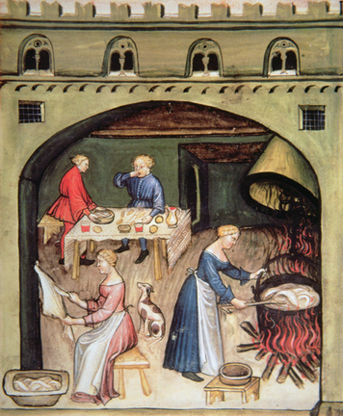Medieval towns were typically small and crowded. Most of the houses were built of wood. They were narrow and could be up to four stories high. As wooden houses aged, they tended to lean. Sometimes two facing houses would lean so much they touched across the street!

Rich and poor lived in quite different households. In poorer neighborhoods, several families might share a single house. A family might have only one room where they cooked, ate, and slept. In general, people worked where they lived. Wealthy merchants often had splendid homes. The first level might be given over to a business, including offices and storerooms. The family’s living quarters might be on the second level. An upper level might house servants and apprentices.

Even for wealthy families, life in a castle was not always comfortable compared to life today. Rooms were cold, smoky, and dim. Fireplaces were the only source of heat, as well as the main source of light. Most windows were small and covered with oiled parchment instead of glass, so little sunlight came through.

Growing up in a medieval town wasn’t easy, either. About half of all children died before they became adults. Those who survived began preparing for their adult roles around the age of seven. Some boys and a few girls attended school, where they learned to read and write. Children from wealthier families might learn to paint and to play music on a lute (a stringed instrument). Other children soon began work as apprentices.

In general, people of the Middle Ages believed in an orderly society in which everyone knew their place. Most boys grew up to do the same work as their fathers. Some girls trained for a craft. But most girls married young, usually around the age of 15, and were soon raising children of their own. For many girls, their education was at home, where they learned cooking, cloth making, and other skills necessary to care for a home and family.

4. Most medieval homes were made of ________________________.

a. stone b. wood c. brick d. concrete

5. Fill in the chart below with descriptors of poor homes and wealthy homes

|  |  |
| --- | --- |
| **Poor Homes** | **Wealthy Homes** |
|  |  |

6. Name two things that made life in these homes uncomfortable.

7. Boys began preparing for their adult roles at age _______________________. Girls were married often at the age of _______________.

8. Put it all together: **Medieval life was difficult, dirty and unfair.**

Prove this statement to be true using evidence from the reading passage. Make sure you write using a PEE style paragraph. Each piece of evidence should be introduced and explained using a quote sandwich.

**Point Statement: Medieval life was difficult, dirty and unfair. ­**_____________________­­­­­­­­­­­­­­­­­­­­­­­­­­­_______

______________________________________________________________________________________________________________________________________________________________________________________________________________________________________________________________________________________________________________________________________________________________________________________________________________________________________________________________________________________________________________________________________________________________________________________________________________________________________________________________________________________________________________________________________________________________________________________________________________________________________________________________________________________________________________________________________________________________________________________________________________________________________________________________________________________________________________________________________________________________________________________________________________________________________________________________________________________________________________________________________________________________________________________________________________________________________________________________________________________________________________________________________________________________________________________________________________________________________________________________________________________________________________________________________________________________________________________________________________________________________________________________________________________________________________________________________________________________________________________________________________________________________________________________________________________________________________________________________________________________________________________________________________________________

Name_________________________________________________

**Exit Slip**

How would your life be different if you lived in Medieval Europe? Where would you live? What would you do during the day? What would you eat? What would you wear? **Respond to the prompt in at least 4 sentences.**

**____________________________________________________________________________________________________________________________________________________________________________________________________________________________________________________________________________________________________________________________________________________________________________________________________________________________________________________________________________________________________________________________________________________________________________________________________________________________________________________________________________________________________________________________________________________________________________________________________________________________________**

**Total Points: ________**