Name_____________________________ Date____________ Unit 5: Medieval Europe
PACKET C
Do Now:
- Copy the objectives from the board:
-Students Will Be Able To: Determine the cause and effects of the Crusades and analyze the language and persuasion of Pope Urban II through guided notes and a close reading.

- Vocab: Match the terms to the definition
_______ 1. Manor
- Kicked out of the Church for disobeying
- Land owned by the noble that housed the nobles, peasants, a church, and farm land
- Middle Ages in Europe
- A political system in which land was exchanged for loyalty and protection
- Not religious
________ 2. Medieval
________ 3. Secular
________ 4. Excommunication
________ 5. Feudalism

- Church Power: Use the pictures below to describe the power of the Church.
The Catholic Church had a large amount of power and wealth in the Middle Ages. List 3 ways the Church got wealth or power.
- ________________________________________________________________________________________________________________________________________________
- ________________________________________________________________________________________________________________________________________________
- ________________________________________________________________________________________________________________________________________________

The Crusades: Guided Notes
The Holy Land
- During the Middle Ages, Christians called Palestine/Israel the “Holy Land” because Jesus had lived there
- Many __________________________ wanted to see the places that Jesus had visited
- The Holy Land had been under Christian control, but was _____________________________________________________who were living there
- They soon began preventing Christians from visiting
- Rumors spread around Europe that Muslims were _________________ Christians and destroying _________________________
Pope Urban’s call
- In 1095, Pope Urban II called on all European Christians to join together to ___________________________________ the holy Crusades or wars against the Muslims
- The Pope wanted to take the Holy Land back from the ____________________________
The Crusades
- Many European ____________________________ made the long journey from Europe to the holy land to defeat the Muslims
- There were ________________ crusades in total

Crusades Map
Directions:
- On your map, circle the holy land.
- Then, trace the route from France to the Holy Land.
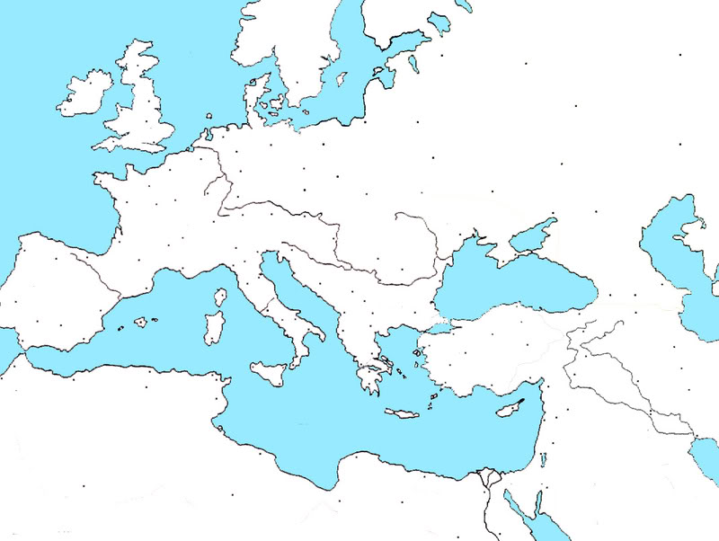

England

France
Spain
Italy

Holy Land

- What difficulties might a crusader face on the journey? ____________________________________________________________________________________________________________________________________________________________________________________________________________________________________________________________
The Crusades
- Reasons people went on Crusades
  - ___________________________________________________________
  - To guarantee their salvation
  - Deep ______________________________________________________

Impact of the Crusades
- It is estimated that almost ___________________________ people died on the crusades
  - This includes Christian crusaders and Muslims, as well as _________________ who were _______________________________ during the holy wars
Impact of the Crusades on Europe
  - ___________________________________________: Kings grew more powerful as knights, nobles, and serfs left to fight which helped to eventually end feudalism
  - Advanced civilization: Europeans brought back _____________________________ ________________________ such as algebra, the compass, and medicine
  - Increase in trade: Merchants became wealthy from trade with Muslims and new economic systems like banks and taxes developed
Impact of the Crusades on Muslims
- Since most of Crusades were fought on ______________________________________, they faced mass destruction and large death-tolls
- There was a smaller _______________________________ impact on the Muslims because Muslim society was much more advanced at the time
  - Learned about new weapons and military ideas
  - Merchants became ______________________________________________________ with Europeans
  - Muslims became united against ___________________________________________
STOP AND THINK
Who do you think “won” the crusades? _______________________________________________
_________________________________________________________________________________________________________________________________________________________________________________________________________________________________________________________
Name_____________________________________________ Date________________ Pd._____
Exit Slip
1. What were two positive effects of the Crusades?
1. _____________________________________________________________ ___________________________________________________________________
2. _____________________________________________________________ ___________________________________________________________________

2. What were two negative effects of the Crusades?
1. _____________________________________________________________ ___________________________________________________________________
2. _____________________________________________________________ ___________________________________________________________________

