Name___________________________________ Period_____Unit 1: Islam

Unit 1: Islam
Packet A
Unit 1 Standards:
DC History Standards
9.1. Students analyze the geographic, political, economic, social, and religious structures of the civilizations of Islam in the Middle Ages.
1. Identify the physical location and features and the climate of the Arabian Peninsula, its relationship to surrounding bodies of land and water, and nomadic and sedentary ways of life. (G)
2. Describe the expansion of Muslim rule through military conquests and treaties, emphasizing the cultural blending within Muslim civilization (Phoenician and Persian) and the spread and acceptance of Islam and the Arabic language. (P, R, M, S)
3. Trace the origins of Islam and the life and teachings of the Prophet Muhammad, including Islamic teachings on its connection with Judaism and Christianity. (G, R)
4. Explain the significance of the Qur’an and the Sunnah as the primary sources of Islamic beliefs, practice, and law, and their influence in Muslims’ daily life. (R, S)
5. Trace the origins and impact of different sects within Islam, including the sources of disagreement between Suunis and Shi’ites. (R, P)
6. Explain the intellectual exchanges among Muslim scholars of Eurasia and Africa and the contributions Muslim scholars made to later civilizations during the Islamic Golden Age in the areas of science, alchemy, geography, mathematics (algebra), philosophy, art, and literature. (I)
7. Describe the growth of thriving cities as centers of Islamic art and learning, such as Cordoba and Baghdad.
8. Describe the establishment of trade routes among Asia, Africa, and Europe; the role of the Mongols in increasing Euro-Asian trade; the products and inventions that traveled along these routes (e.g., spices, textiles, paper, steel, and new crops); and the role of merchants in Arab society. (G, I, E)

Common Core Standards
CCSS.ELA-LITERACY.RH.11-12.1
Cite specific textual evidence to support analysis of primary and secondary sources, connecting insights gained from specific details to an understanding of the text as a whole.
CCSS.ELA-LITERACY.RH.11-12.3
Evaluate various explanations for actions or events and determine which explanation best accords with textual evidence, acknowledging where the text leaves matters uncertain.
CCSS.ELA-LITERACY.RH.11-12.9
Integrate information from diverse sources, both primary and secondary, into a coherent understanding of an idea or event, noting discrepancies among sources.

Grading:
Each assignment will be graded in the following way:
Do Now: 10 points Participation
Exit Slip: 10 points Participation
Notes: 50 points Participation
Readings/Reading Questions: 50 Points Classwork/Homework
Worksheets: 50 points Classwork/Homework
Homework: 50 points Classwork/Homework
-Late assignments: 10 points will be deducted for each late class day-
A
Name_____________________________ Date____________ Unit 1: Islam
Do Now:
Total Points: ________

- Copy the objectives from the board:

-Students Will Be Able To:
- Describe the __________________________________ of Islam

- Map Quiz Practice
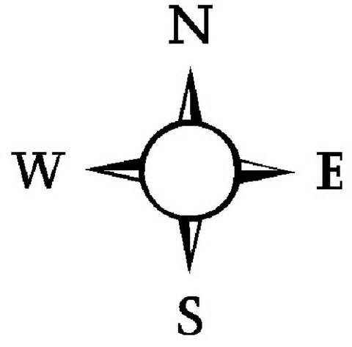
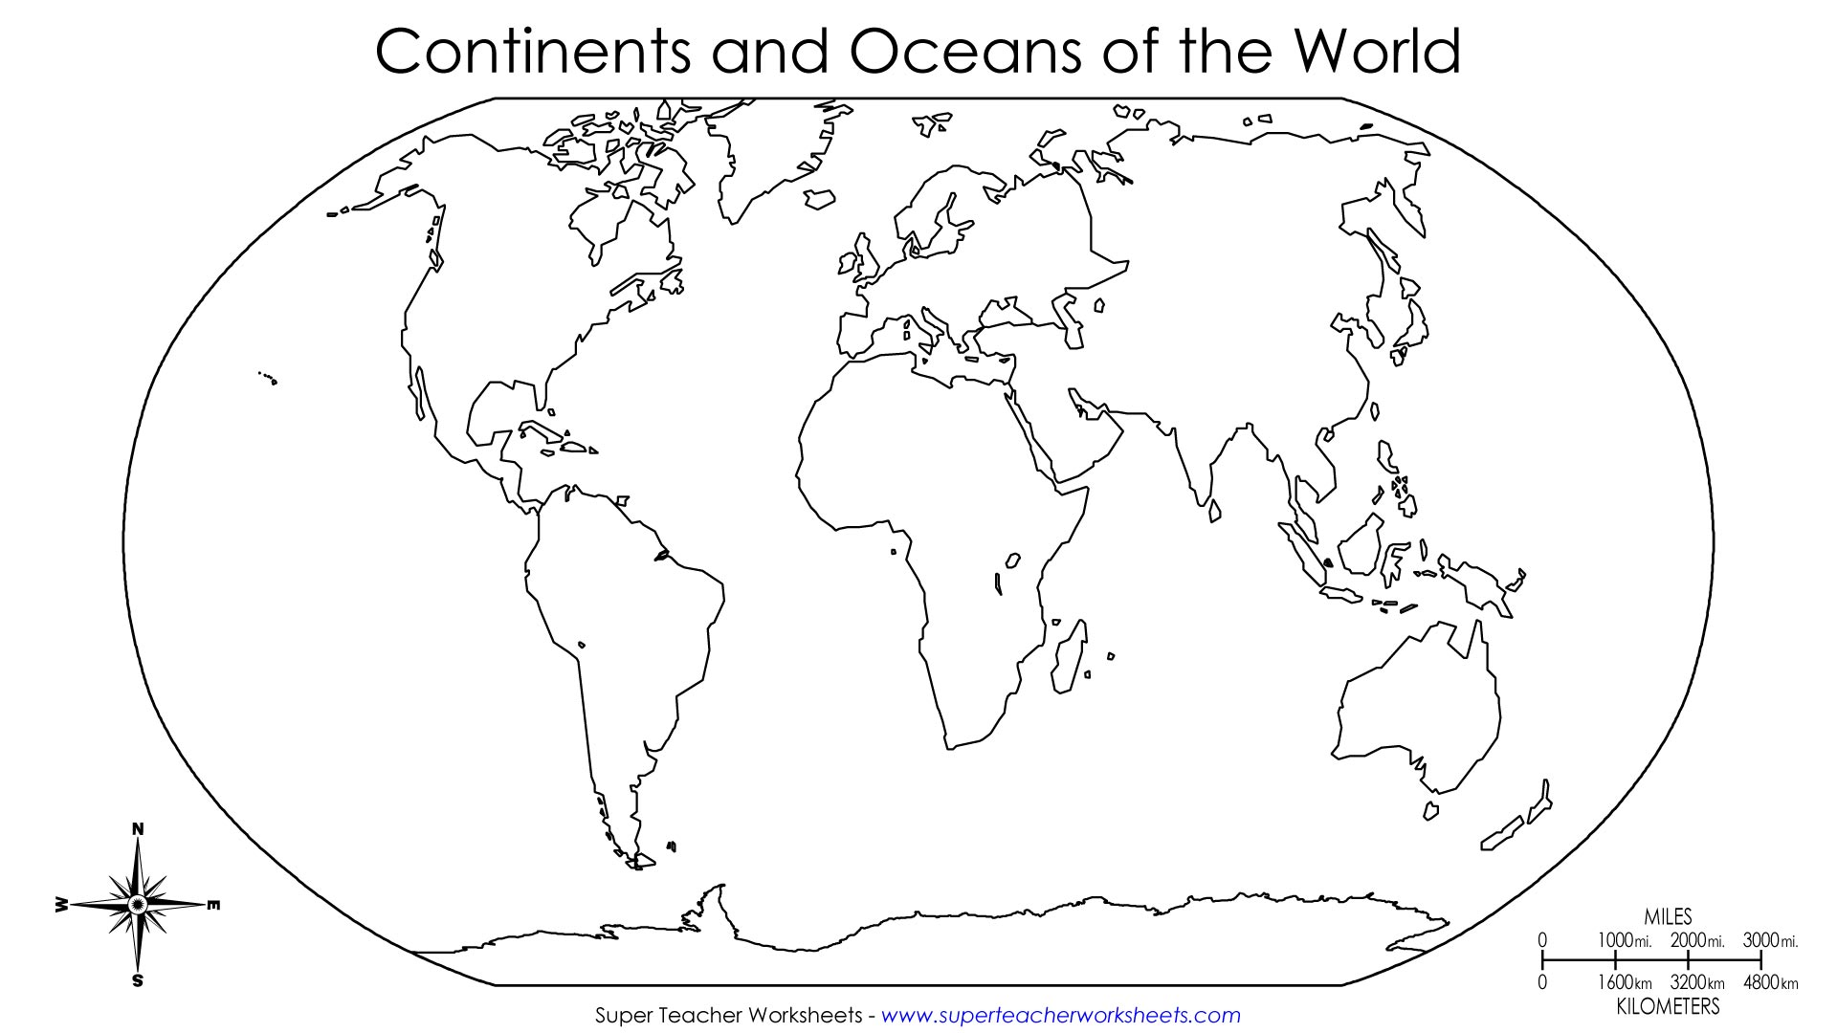
^{3.}
^{4.}
^{2.}
^{1.}
Continents
- Europe
- Africa
- Asia
- Australia
- North America
- South America
- Antarctica

Oceans
H. Indian Ocean
I. Pacific Ocean
J. Atlantic Ocean
K. Southern Ocean
L. Arctic Ocean

- Fill in the 4 blanks on your map with the corresponding Continent or Ocean.

- Extra Practice
- Which continent is directly south of Europe? _______________________________

- Which ocean is west of North America? _______________________________

- Which ocean is east of Africa and south of Asia? ___________________________
A
Notes on beliefs of Islam—Follow along with the powerpoint on the board. Silently fill in the guided notes below as Ms. Gamoran goes through the powerpoint. You will be asked to complete a “THINK PAIR SHARE” with your partner at several points throughout the powerpoint.
Total Points: ________
ISLAM NOTES Part 1
What is Islam?
- A religion
- ____________________ people practice Islam (total population is 7 billion people)
- People who practice Islam are called _____________________
- Islam means “peace through _____________________________________________”
- Islam began in the __________________________________, after the prophet ____________________ heard messages from god.

What do Muslims believe?
- Islam is a monotheistic religion. This means that Muslims believe in ______________________.
- Muslims use the ___________________ word for god, __________________.
- The holy book of Muslims is called the _____________________ (Qur’an). The Koran includes many stories from the _____________________________________, as well as messages delivered to the prophet __________________________.
- Muslims believe Jesus was a prophet, but was not ___________________, and did not die for their _________________
- Muslims believe that ____________________ was the last prophet.

What are Muslim practices?
- Muslims pray in a __________________.
- The most sacred mosque in Islam is called the _________________, which is in __________________________.
- The holy day of Islam is _____________________________.
- The Koran forbids Muslims from eating _________________ and drinking alcohol
- Muslims must fulfill the _____________________________ of Islam.
A

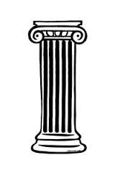

Shahada Salat Zakat Sawm Hajj _____________________ ______________________ _____________________ ____________________ _____________________
Muslims must make this pilgrimage to ____________ at least ____________________ in their lifetime, if they can afford to.

Declaration of ___________________. “There is no god except______________; Muhammad is the messenger of Allah.

Giving __________ (about 2.5% of savings) to ________________, perhaps for the poor.

Muslims must not _______ food or ____________ during the month of Ramadan during ____________ hours.

Praying ______ times a day, facing the holy city of __________. Before praying, people must __________ their hands and feet.

THINK PAIR SHARE

How do the five pillars of Islam shape the lives of Muslims?

____________________________________________________________________________________________________________________________________________________________________________________________________________________________________________________________________________________________________________________________________________________________________________________________________________________________________________________________________________
A

Exit Slip:
Total Points: ________

- Vocabulary Practice: Match the term with its definition
- A person who follows the religion of Islam

- Requirements of Muslims, includes testimony of faith, prayer, charity, fasting, and pilgrimage

- Religion that means “Peace through submission to God”

- Belief in one god

_______ 1. Monotheistic

_______ 2. Islam

_______ 3. Muslim

_______ 4. 5 Pillars of Islam

II. Basic Beliefs of Muslims

In your opinion, what are the three most important beliefs of Muslims?

1.___________________________________________________________________________________________________________________________________________________________

2.___________________________________________________________________________________________________________________________________________________________

3.___________________________________________________________________________________________________________________________________________________________

A
Name_____________________________ Date____________ Unit 1: Islam
Packet B
DO NOW:
Total Points: ________

- Copy the objective from the board:
-Students Will Be Able To:
- Describe the similarities and differences between __________________, ____________________, and _____________________________.

- Multiple Choice: Answer questions 4-5 based off the following quotes from the Koran:

“(17:26-29) You shall give the due alms to the relatives, the needy, the poor, and the travelling alien, but do not be excessive, extravagant.”

4. The quote above most likely represents which of the Five Pillars of Islam?
- Sawm
Hint! Look at your notes on the Five Pillars for help!
- Hajj
- Zakat
- Shahada

"(2:187) You may eat and drink until the white thread becomes distinguishable to you from the dark thread at dawn. Then you shall maintain the fast until the night."
- The quote above most likely represents which of the Five Pillars of Islam?
- Salat
- Sawm
- Zakat
- Shahada

III. Vocabulary Practice: Match the term with its definition

_______ 1. Koran
- Muslim name for God, in Arabic

- Muslim holy book

- Muslim place of worship

_______ 2. Allah

_______ 3. Mosque
B
Assignment: Comparing 3 Monotheistic Religions

Background:
Three of the world’s major religions, Judaism, Christianity, and Islam, all began in the Middle East and are all linked to each other. Today we will explore the major similarities and differences between the three major religions. We will investigate Judaism and Christianity, and dive deeper into some of the beliefs and practices of Islam.

Directions:
Read the excerpts on Judaism, Christianity, and Islam from the class handouts. Use the chart to guide your reading. Fill in the information as you read. If you have vocabulary questions, please quietly raise your hand and Ms. Gamoran will assist you.

B
Fill in the chart below with information from the readings and your notes.
 | Judaism | Christianity | Islam  (Hint! Start with your notes to fill in this section)
Name for people who practice the religion
Holy Book
Holy Day
Place of Worship
Key Beliefs
Sects (groups within the religion)
Practices and Rituals

INTENTIONALLY LEFT BLANK

B
Total Points: ________
Total Points: ________
Islam
Wait to fill out! We will fill this out as a class.

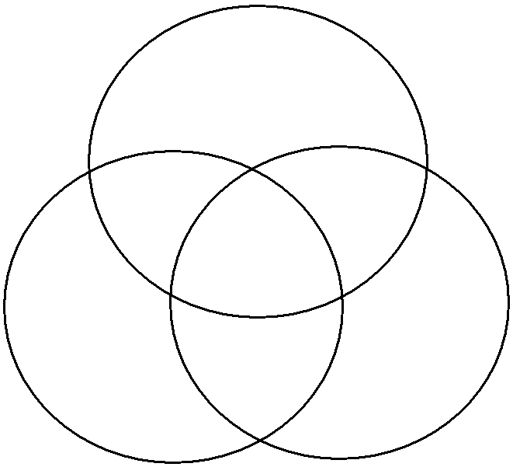
B 10
Christianity
Judaism
All 3
I + J
J + C
I + C

Exit Slip:
Total Points: ________
- What are 3 things that all 3 religions have in common?
- ________________________________________________________________
- ________________________________________________________________
- ________________________________________________________________

- If these three religions have so much in common, why do you think there is still conflict and fighting all over the world because of religion?
__________________________________________________________________________________________________________________________________________________________________________________________________________________________________________________________________________________________________________________________________________________________________________________________________________________
B
Name_____________________________ Date____________ Unit 1: Islam
Packet C
DO NOW:
- Copy the objective from the board:
Total Points: ________
-Students Will Be Able To:
- Describe the origins of ________________________
- Evaluate the impact of the location of the Arabian Peninsula’s location on Islamic _____________________________________.
- Construct a PEE paragraph
II. The map below shows the modern day distribution of the followers of Islam all around the world. Look at the map below, and then answer the following questions.
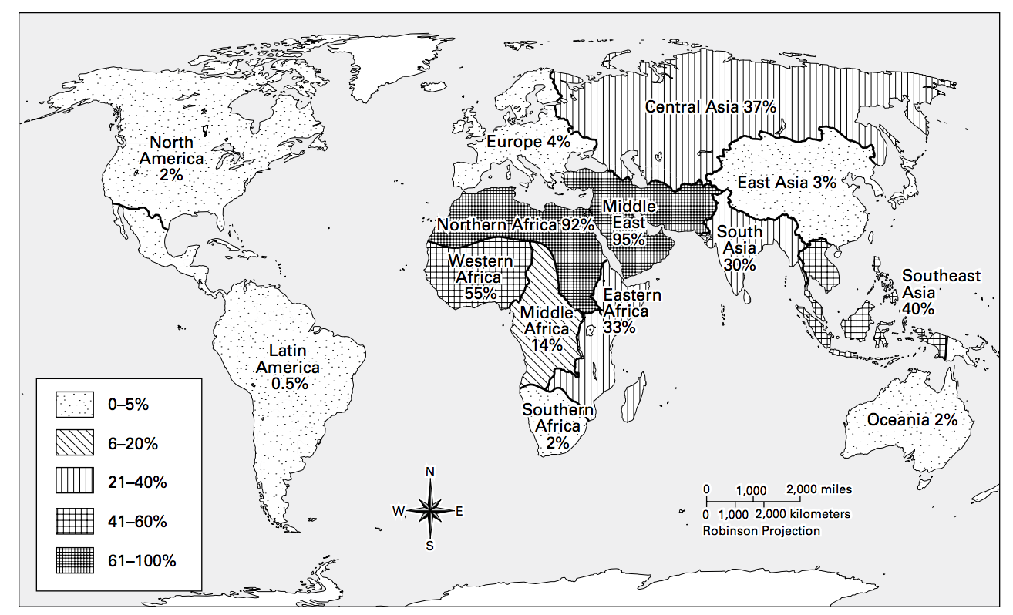

- Which pattern on the map represents the highest concentrations of Muslims? The lowest?

- In what regions of the world do the most Muslims live? The fewest?

- Based on this map, in what region of the world do you think the Islamic faith may have originated? Why?
C

Total Points: ________
Directions: Read the reading on the left about the origin of Islam, and answer the corresponding questions on the right.
How Did Islam Begin?

1.1 Background
Islam began in Mecca, a city in the Arabian Peninsula, which is a part of Southwestern Asia. The city of Mecca was located in a dry, rocky valley in the west. Mecca did not have agriculture; there was very little farming possible. Instead, Mecca became wealthy because it was a center of trade. Merchants* traveling along trade routes stopped at the city’s market and inns. They bought spices, sheepskins, meat, dates, and other products from townspeople. Merchant families grew wealthy through trade. Over time, a handful of families had come to rule the city. These families would not share their wealth with the weaker, poorer clans who lived there.

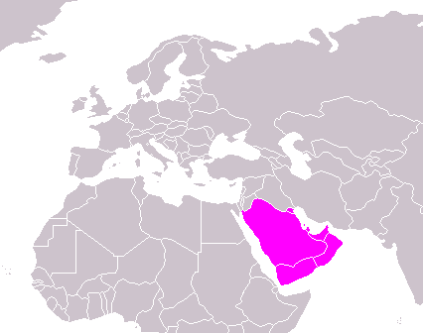

Mecca was also a religious center. According to the Koran, Abraham had built the cube-shaped shrine*, the Kaaba, centuries before, to honor God. Most Arabs followed polytheism, and the Kaaba had hundreds of idols (statues of different gods). People from all over the Arabian Peninsula came to worship at Mecca.

*Merchant—a person who buys and sells goods, a trader
*shrine—a place or monument that is considered holy (religious)
1. How did the Arabian Peninsula gain wealth?

_____________________________________________
_____________________________________________
_____________________________________________
_____________________________________________
_____________________________________________
_____________________________________________
_____________________________________________

2. Using the map, why do you think the Arabian Peninsula was a good place for trade with other peoples?
________________________________________________
________________________________________________
________________________________________________
Asia
Europe
________________________________________________
________________________________________________
________________________________________________
Arabian Peninsula
________________________________________________
Africa
________________________________________________

3. Polytheism most likely means:
  - Belief in one God
  - Belief in idols
  - Prayer at the Kaaba
  - Belief in many Gods

C
4. Underline the job Muhammad had as a boy. Circle the job Muhammad became when he grew up.
1.2 Muhammad’s Life
Around 570 C.E., a boy named Muhammad was born in Mecca. After his mother died, Muhammad’s uncle, a merchant, took care of Muhammad. As a boy, Muhammad was a shepherd, and took care of his family’s flocks of sheep and goats. When he got older, he became a successful merchant, like his uncle. When Muhammad was 25, he married Khadija, a widow who owned a successful trade business.

For the next 15 years, Muhammad worked as a merchant. He also cared about spirituality. He often spent time praying and meditating in the mountains around Mecca. He was concerned about the effects of wealth and the worship of the idols on his city. He believed the wealthy were greedy should have been doing more to help the poor.

5. What problems did Muhammad have with the people of Mecca?

_____________________________________________
_____________________________________________
_____________________________________________
_____________________________________________
_____________________________________________
_____________________________________________
_____________________________________________

6. What do you think the word prophet means?

- Someone who listens to God
- A person who lives in the Arabian Peninsula
- Someone who talks to God and spreads God’s message
- A person who marries God
1.3 Origin of Islam

In about 610 C.E., when Muhammad was 40, he went to meditate in a cave in the mountains. There, according to Islamic teachings, the angel Gabriel visited Muhammad. Gabriel told Muhammad, “You are the messenger of God.” At first Muhammad feared that he might be going crazy. But Khadijah supported Muhammad and told him that she believed that Allah had chosen him as a prophet to spread Allah’s words to the people.

Gradually, a small group of followers of Islam (Muslims) developed at Mecca. For Muslims, Islam was a way of life and the basis for creating a fair society. For example, at the time women had few rights. Muslims granted more rights to women.

Around 613 C.E., Muhammad began to speak to other people in Mecca. He taught that people must worship one God, Allah, that all believers in God were equal, and that the rich should share their wealth. He urged people in Mecca to take care of the poor and to improve the rights of women. Some members of Muhammad’s family became Muslims. People from other families joined him also.

7. Underline the sentences that helped you understand what the word prophet meant.

8. Summarize Muhammad’s teachings in your own words.
_____________________________________________
_____________________________________________
_____________________________________________
_____________________________________________
_____________________________________________
_____________________________________________
_____________________________________________

C
9. Why did some people dislike Muhammad’s teachings?
Most people of Mecca, however, rejected Muhammad’s teachings. Mecca’s leaders did not want to share their wealth. They also feared that if Muhammad grew stronger, he would take power away from them. Muhammad’s monotheistic teachings also angered people who did not want to stop believing in many gods.

To stop the spread of Muhammad’s teachings, some people called Muhammad a liar. Some people attacked his followers. Despite this treatment, the Muslims would not give up their faith. As Muslims came under more attacks, Muhammad looked for a new home. In 622, Muhammad and his followers left Mecca and traveled to the city of Medina on a journey known as the hijrah (HEEJ-rah). Medina was a city ready to accept Muhammad and Islam. In Medina, Muhammad created a new Muslim community as more people converted* to Islam. Although they did not follow Islam, Muhammad asked Muslims to respect Christians and Jews. They, like the Muslims, believed in the one god.

By 630, Muhammad had gained many followers of Islam. He and his followers returned to Mecca and defeated those who opposed him. After this time, Islam continued to grow and spread across the Arabian Peninsula.

*Converted—to change a person’s religion

_____________________________________________
_____________________________________________
_____________________________________________
_____________________________________________
_____________________________________________
_____________________________________________
_____________________________________________

10. Fill in the blank.
The hijrah was Muhammad and his followers’ journey from_______________________________ to
_________________________________.

10. The hijrah is often referred to as a turning point in Islam. List 2 pieces of evidence that support this point.

- _________________________________________
_____________________________________________
_____________________________________________
- __________________________________________
____________________________________________
______________________________________________________
______________________________________________________
C
The PEE Method to Writing
Total Points: ________
The PEE system is an easy way to structure your writing to make sure you are always getting across the main ideas and also supporting your idea. You can make any statement you want to, but what makes it strong is how you are able to support it!
POINT
What is your point? What are you trying to say?
EVIDENCE
If you’re making a point you have to prove its true and use evidence. Evidence can be a summary of the text, data, statistics or a direct quote.
EXPLAIN / EXPLORE
Now you have to explain your evidence and make the connection to your point. Make sure you have a good level of analysis.

Let’s do an example using the topic of seasons.
Your prompt: Which season has the most enjoyable activities, spring, summer, winter, or fall?
1. Point-State which season is most enjoyable:
___________________________________________ is the most enjoyable season.
2. Evidence-Can you prove this to be true? Try and think of three reasons that make the season you chose most enjoyable:
a. First,___________________________________________________________________________ _________________________________________________________________________________________________________________________________________________________________
b. Also, ________________________________________________________________________
_________________________________________________________________________________________________________________________________________________________________
c. Lastly, ________________________________________________________________________
_________________________________________________________________________________________________________________________________________________________________
3. Explain- Now, explain how your evidence proves your point and examine your evidence more in depth.
These examples show ____________________________________________________________
___________________________________________________________________________________________________________________________________________________________________________________________________________________________________________________
C
INTRO TO PEE
Can you find the Point, Evidence, and Explanation in the following paragraph?
Next to each statement write the word Point, Evidence or Explanation.

___________ a. All three religions are monotheistic, which means they all believe in one god.

___________ b. Islam, Christianity, and Judaism have many similarities.

___________ c. Also, all three religions have their own place of worship.

___________ d. This shows that Islam, Christianity, and Judaism have many similarities in their practices and beliefs.

___________ e. Lastly, Islam, Christianity, and Judaism all have a holy book.

What order should these statements go in to make a paragraph? See if you can place them in order. Use just need to write the letter on the line.

1st sentence:______
2nd sentence: _____
3rd sentence: _____
4th sentence: _____
5th sentence: ______

See how easy it is to write a good paragraph! Don’t worry, we will practice this a lot this year…

C
The PEE Method- Using it with content
Total Points: ________
The Rise of Islam Writing Prompt

Write your own PEE paragraph using our content from today- Choose ONE of the prompts below to complete the PEE method for.

- Prompt 1: Explain how Muhammad could be considered the most important person for the religion of Islam
- Prompt 2: Explain why the Hijrah can be seen as a turning point in Islam.
- Prompt 3: Explain why spreading the word about Islam would have been difficult during the Middle Ages

Point: ________________________________________________________________
__________________________________________________________________________________________________________________________________________
Evidence: ___________________________________________________________
__________________________________________________________________________________________________________________________________________

Evidence: ___________________________________________________________
__________________________________________________________________________________________________________________________________________

Evidence: ___________________________________________________________
__________________________________________________________________________________________________________________________________________

Explanation: _______________________________________________________
__________________________________________________________________________________________________________________________________________
C

Exit Slip: Birth of Islam Timeline
Total Points: ________

Directions: Place the following events in order on a timeline:

- Muhammad and his followers leave on the hijrah
- Fighting breaks out between the Muslims and the Meccans
- Muhammad is a sheep herder
- Muhammad hears messages from Allah through the Angel Gabriel
- Muhammad develops a new Muslim community in Medina
- Muhammad marries Khadija
- Muhammad begins to preach
- Muhammad and the Muslims return to Mecca

C

C
Name_____________________________ Date____________ Unit 1: Islam
Packet D
DO NOW:
- Copy the objective from the board:
-Students Will Be Able To:
- Explain the ______________ in Islam after __________________________________ death and differentiate between the two resulting denominations

- Quiz Review: Answer the following multiple choice questions
- What is the hijrah
  - Pilgrimage to Mecca that all Muslims must take once in their life
  - Muhammad’s wife
Total Points: ________
  - Muhammad’s journey from Mecca to Medina
  - The 1st pillar of Islam, a testimony of faith
- What is the vocab term for belief in one God?
  - Monotheism
  - Shahada
  - Polytheism
  - Allah
- During what month do Muslims fast?
  - Ramadan
  - April
  - Safar
  - Rabi
- What is the Jewish place of worship called?
  - Mosque
  - Church
  - Synagogue
  - Torah
- What is the Muslim place of worship called?
  - Kaballah
  - Mosque
  - Church
  - Synagogue
- What is the Muslim holy book called?
  - Torah
  - Qu’ran
  - Bible
  - Mosque
- Which religion has a holy day on Saturday?

  - Judaism
  - Christianity
  - Hinduism
  - Islam
D

ISLAM NOTES Part 2
Total Points: ________
Review Video: Answer the questions as you watch the video

1. Describe what you see in the opening scenes. Describe the landscape of the Arabian Peninsula.

2. Why is Khadija, Muhammad's wife, so important to the religion of Islam?

3. How long did Muhammad receive messages from Allah that became the Koran?

4. How did the first Muslim followers spread the Koran and receive the teachings from Muhammad?

What happened after Muhammad died?
- After the death of Muhammad, Islam faced a _______________________.
- Muhammad had no ___________________ to lead after him, and did not leave instructions on how to choose next ________________________, or leader of Islam
- Muslims split into two _____________________________, or groups because they disagreed on how to choose a leader.
  - Sunni
  - Shia

What did Sunni Muslims want?
- The Sunni believed that the next caliph of Islam should be ____________________ by the Muslims
- This person would be the person most _________________________________________________________.
- ____________________ Muslims wanted Abu Bakr, one of Muhammad’s closest ____________________________ to be the next caliph

What did Shia Muslims want?
- The Shia believed that the next caliph of Islam should be someone ____________________________________________________________.
- It was a normal custom at the time to pass down leadership through ________________ family members
- They wanted _________________, Muhammad’s son-in-law to become the next _______________________.

What happened between the Sunni and Shia?
- Fighting continues between the Sunni and Shia even today.
- By the mid-600s, the Sunni, who were ______________________________, had control, and Islam had an ______________________________________
- Despite the violence between the two denominations, throughout this time, Islam began to spread quickly through _________________________________________________________________.

THINK PAIR SHARE
Why do you think a disagreement over who should be leader caused such a large split?
________________________________________________________________________________________________________________________________________________________________________________________________________________________
Can you think of another example where a minor difference in opinion caused a large split in a group or religion?
________________________________________________________________________________________________________________________________________________________________________________________________________________________
D
Why did Islam spread so quickly?
- Life in the desert was harsh.
- People lived ____________________________ lives, they ______________________ from place to place in search of food and water.
- People stopped at _____________________________________________.
- The caliphs wanted to _____________________________ their empire both politically and religiously
- They used ___________________________________ and often faced weak empires
- To many Muslims, this signaled ____________________________ support for Islam, and they were able to gain support of conquered people
- Islam also appealed to many people.
  - Basic Beliefs
  - ______________________________
  - Rights for __________________________
  - ____________________________________
- Some people were forced to ________________________________ to Islam
- Others were required to pay ______________________________ if they did not convert
- Muslims had good relations with conquered “People of the Book”
  - Jews and Christians

THINK PAIR SHARE

Why do you think Islam was able to spread so far and so fast?
__________________________________________________________________________________________________________________________________________________________________________________________________________________________________________

SPREAD OF ISLAM: The Ottoman Empire

There were a number of Islamic Empires that rose and fell after the death of Muhammad. One of the largest and most powerful Islamic Empires was the Ottoman Empire. The Ottomans were a Turkish-speaking nomadic group. The Ottoman Empire spread across Asia and into southeastern Europe. The most important leader of the Ottomans was Suleiman the Magnificent. Under Suleiman’s rule, the Ottoman Empire reached its largest extent. He was a brilliant military leader. Suleiman encouraged law, and arts and architecture. Muslim society flourished under him.
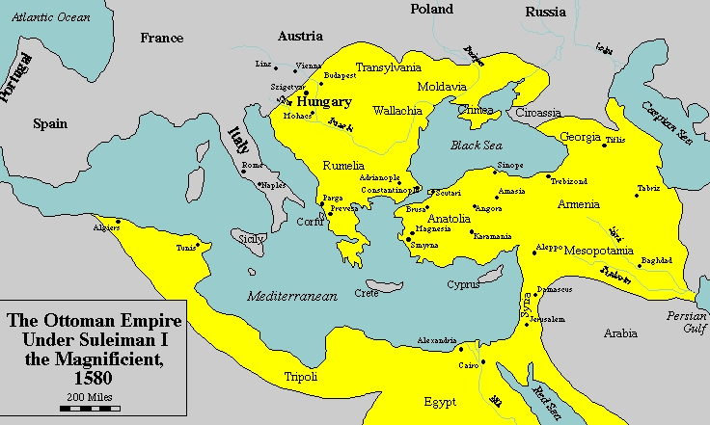

Under the Ottoman Empire, Istanbul became a very powerful Muslim city. Istanbul became not only a political and military capital, but because of its position near Europe, Africa, and Asia, it became one of the great trade centers of the world. This was a time of great wealth.

- How did Istanbul’s location help the Ottoman Empire become a wealthy Empire? ___________________________________________________________________________
_________________________________________________________________________________________________________________________________________________________________________________________________________________________________
_________________________________________________________________________________________________________________________________________________________________________________________________________________________________
D
Total Points: ________

D
Golden Age in Islam (Notes Continued)
What was the Golden Age of Islam?
- During the Golden Age of Islam, Muslims made advances in economics, art, literature, and science
- _______________________________________-Muslims built a vast trading network across the Muslim world and beyond.
What achievements did Muslims have during the Golden Age?
- ART- Muslims artists perfected skills in__________________________________ and arabesque
- In Jerusalem, Muslim architects built the_____________________________________, a great shrine capped in magnificent dome.
- Arab writes wrote ____________________________________ and told tales
- Muslims made advances in Mathematics, ___________________________ and Medicine
- The greatest Muslim mathematician is al- Khwarizmi, who pioneered the study of Algebra.
- Muhammad al-Razi was a famous________________________________ , who wrote many medical books and studies small pox and measles

Exit Slip
Total Points: ________
I. As you learned today, Muslim empires used many different tactics to expand their territory across the globe. Fill in the chart below with four specific pieces of evidence that prove that Muslims were successful conquerors.

Muslims were successful conquerors

D

Name_____________________________ Date____________ Unit 1: Islam
DO NOW:
Total Points: ________
Packet E
- Copy the objective from the board:
-Students Will Be Able To:
- Evaluate the impact of the 9/11 attacks on the ________________________ community.

II. Multiple Choice: Answer questions 1-5 based off the chart below.

September 11th by the Numbers
Total number killed in attacks in NY | 2,763
Tons of debris removed from the site | 1.8 million
Number of children who lost a parent | 3,051
Jobs lost in NY because of the attacks | 146,100
Number of families who lost a spouse or partner | 1,609
Percentage of Americans who knew someone hurt or killed in the attacks | 20%
Time it took for towers to fall | 12 seconds

- How many total people were killed in the attacks?

- How many children lost a parent in the attacks?

- What percentage of Americans knew someone hurt or killed in the attacks?

- How long did it take for the towers to fall?

- In your opinion, how do statistics affect our feelings and emotions about tragic events?

6. Read the following paragraph and Underline words that show this student’s emotions during the 9/11 attacks.
Passage 1: "Go back, run!"
The lights flickered and went out. Then we heard a really loud crash. We ran to the windows and saw tons of people running up the streets from the towers. I ran to the other side of the school, and saw the first building collapsing. It was coming in on itself. Dark black smoke was going everywhere. I saw people screaming. I was stunned.
The assistant principal said for all of us to go to our homerooms. Then, he told us to walk up the West Side Highway with our teacher. A policeman was standing in front to direct us. We were walking forward when suddenly he said, "Go back, go back into the school!" We turned around and I saw smoke. We started to jog back, and then the policeman screamed, "No, wait, go back, run!" That's when I saw more smoke coming around the other side of the school. This big cloud of black smoke from the second Trade Center tower was enveloping the whole school.
It was unreal.
(Jack Kirkland, 13, goes to Stuyvesant High School in New York City, near the World Trade Center.)
Total Points: ________

Images and Videos Graphic Organizer- Record your thoughts and notes as you view the images and videos
What you see? | Facts you learned | Emotions/Feelings | Questions you have

Total Points: ________
Name______________________________________________ Date_______________ Period_____
September 11th Mini DBQ
(Document Based Question)
Historic Context: On September 11th, 2001, 19 radical Muslims took over four airplanes and carried out terrorist attacks against the United States. Two planes were flown into the towers of the World Trade Center in New York City, a third plane hit the Pentagon just outside Washington, DC, and the fourth plane crashed in a field in Pennsylvania. Often referred to as 9/11, the attacks resulted in the death of over 3,000 people in New York City and Washington DC. After the attacks, American citizens were terrified and shocked and looked for someone to blame for the terrible events. Many looked towards the Muslim citizens in the country.

Task: Discuss the treatment of Muslim Americans after 9/11 and how Muslim lives’ changed after 9/11.

Part A: The documents below relate information about Muslims in the United States after the September 11th attacks. Examine each document carefully, and then answer the questions that follow it. These answers will help you in part B.
Document 1
The week after 9/11 was awful. Everything was shut down for days — transportation, schools, stores. My family and I stayed in the house the entire week. My father was afraid to let us out because of the violence against Muslims. We heard horror stories about Muslims who were beaten and women who had their scarves ripped off their heads. Some were even raped.
I was so angry. I was furious that these men, who claimed to be Muslim, would do such a thing. Who would kill thousands of innocent people? Don’t they know that these acts of violence would affect all of us? I wanted to get in front of a camera and explain to everyone, “We’re not all the same. We condemn this violence. This is not what our religion teaches us. We’re supposed to be peaceful. The Koran tells us that killing one person is like killing all of humanity.”
-Zahra Huber, a reporter, editor, and producer at CBS News in Detroit
- Why didn’t Ms. Huber’s father want the family to go outside?
______________________________________________________________________________________________________________________________________________________________________________________________________________________________________________________________________________
- According to Ms. Huber, do all Muslims believe in committing terrorist attacks? Why or why not?
_____________________________________________________________________________________________________________________________________________________________________________________________________________________________________________________________________
E
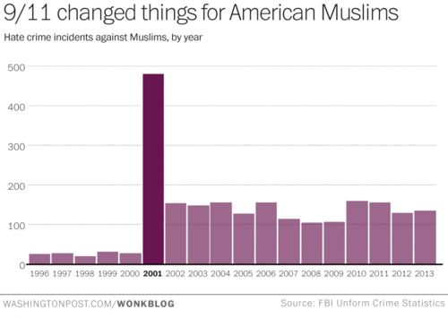
Document 2
After September 11th, 2001, Muslims faced a drastic increase in hate crimes. A hate crime is a crime motivated by racial, sexual, or other prejudice, typically one involving violence. Although the September 11th attacks were carried out by a few radical Muslims, many Americans blamed all Muslims, and targeted American Muslims in their communities.

- What does the graph show increased in 2001? ______________________________________________
- How many more hate occurred in 2001 than in 2000? Answers can be estimated. __________________
Document 3
Many Muslim travelers say that since the Sept. 11 terrorist attacks they have been singled out for questioning by the police and security workers at American airports. Muslim women have been told to remove their headscarves at airport security checkpoints, which is a violation of their beliefs.
The American-Arab Anti-Discrimination Committee has received reports from 21 Arab and Muslim travelers who were evicted from their flights after pilots or flight attendants refused to travel with them because of the way they look or because they had Arabic-sounding names.
E
''This is outright discrimination and prejudice,” said one Muslim airline passenger. “It's making decisions on how people look and what their names sound like. This didn’t happen before, and shouldn’t be happening in America.''
-Laurie Goodstein, New York Times, November 11, 2001.
- What happened to Muslims in airports after the September 11th attacks? _______________________
_________________________________________________________________________________________________________________________________________________________________________________________________________________________________

- How did this change the lives of Muslims?____________________________________________ ______________________________________________________________________________________________________________________________________________________
E
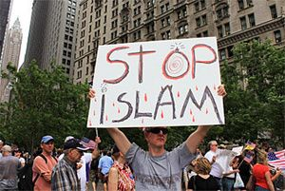
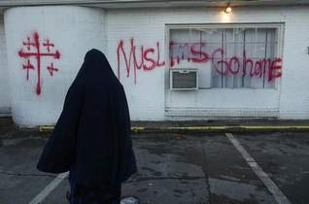
Document 4

- What do the images show about American reactions towards Muslims after 9/11?
____________________________________________________________________________________________________________________________________________________________
Part B: Mini Essay Task: Using the documents above, your answers to the questions in Part A and your knowledge of social studies, write a well-developed paragraph that explains how Muslims were treated and how their lives changed after 9/11. (USE PEE and USE 3 Pieces of Evidence!)
________________________________________________________________________________________________________________________________________________________________________________________________________________________________________________________________________________________________________________________________________________________________________________________________________________________________________________________________________________________________________________________________________________________________________________________________________________________________________________________________________________________________________________________________________________________________________________________________________________________________________________________________________________________________________________________________________________________________________________________________________________________________________________________________________________________________________________________________________________________________________________________________________________________________________________________________________________________________________________________________________________________________________________________________________________________________________________________________________________________________
E
Total Points: ________
Exit Slip
Total Points: ________

- What does DBQ stand for?

- How do you think you did on the mini DBQ today? Write 2-3 sentences or draw a picture that shows you feel.

- Next class we will be starting a Portfolio Project. What is Portfolio and why is it important?
E

