Name_____________________________ Date__________ Unit 6: Renaissance and Reformation
A BRIEF Biography of Galileo and his “Dangerous” Idea

Galileo was born in Pisa, Italy on February 15, 1564. He was an inventor and philosopher. Like many men during the Scientific Revolution he questioned the world around him and wanted to uncover the truth. Galileo is most famous for his views on the universe. It was these views that got him into trouble with the church. His discoveries were revolutionary and earned him the title “Father of Modern Science.”

Galileo invented many mechanical devices. He invented a thermometer, compass, telescope, and pendulum clock. Each of these discoveries he made to help him study the world around him. Perhaps his most famous invention was the telescope. Galileo made his first telescope in 1609, modeled after telescopes produced in other parts of Europe that could magnify objects three times. He created a telescope later that same year that could magnify objects twenty times. With this telescope, he was able to see details in the universe that no one had seen before.

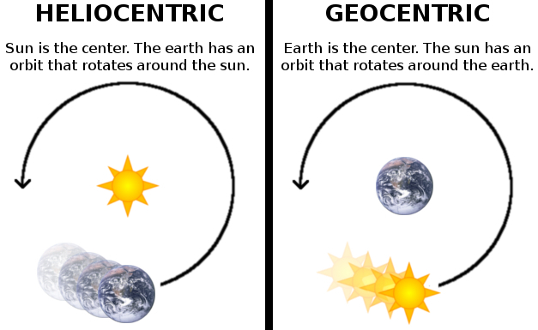
His discoveries proved the Copernican system, or heliocentric theory of the Universe. This system states that the earth and other planets revolve around the sun. Prior to the Copernican system, there was a different view of the universe. This view had been held for hundreds of years. The old theory was known as the geocentric theory. In the geocentric theory, it was believed that the earth was at the center of the universe and everything revolved around it. This would mean that the sun revolved around the earth.

Galileo's belief in the Copernican System (the model of the universe where the sun is the center) eventually got him into trouble with the Catholic Church. The Catholic Church had long upheld the belief that the universe was geocentric. The church leaders feared Galileo’s ideas and found them dangerous. The Church believed that the Bible proved that the earth was the center of the universe and the sun travelled around it.

But what evidence did the church have that Galileo was wrong? Below are several of the quotes from the Bible that the church used to uphold their belief that the universe was geocentric:

“Tremble before him, all the earth!
The world is firmly established; it cannot be moved.”
-1 Chronicles 16:30-

He set the earth on its foundations;
it can never be moved.
-Psalm 104:5-

The sun rises and the sun sets, then hurries around to rise again
-Ecclesiastes 1:5-

The Pope worried that if Galileo’s ideas were proven correct- it would prove the church was wrong. If the Church was wrong about the universe, what if they were wrong about other things as well? The Catholic Church had just been through the Reformation and was still dealing with people becoming Protestants- they wanted to hold onto their control.

The Inquisition was a permanent institution in the Catholic Church charged with getting rid of people who spoke against the beliefs of the church. A committee of people declared to the Inquisition that the Copernican proposition that the Sun is the center of the universe was unbiblical and wrong. Around 1630, Galileo published a book, Dialogue Concerning the Two Chief World Systems, in which he supported the Copernican theory of the universe. Galileo was called to Rome in 1633 to face the Inquisition. Galileo was charged with heresy (speaking out against the church) for his book.
Opening Statement:
Lawyer for the Roman Catholic Church/Lawyer for Galileo
Introduction  - Greet the judge  - Give your name  - Discuss who your client is | _____________________________________________________________  _____________________________________________________________  _____________________________________________________________  _____________________________________________________________  _____________________________________________________________  _____________________________________________________________  _____________________________________________________________  _____________________________________________________________  _____________________________________________________________  _____________________________________________________________  _____________________________________________________________
Claim  - Explain what you will be proving in the trial | _____________________________________________________________  _____________________________________________________________  _____________________________________________________________  _____________________________________________________________  _____________________________________________________________  _____________________________________________________________  _____________________________________________________________  _____________________________________________________________
Opponent’s Argument  - Explain what your opponent will argue  - Explain why they are wrong | _____________________________________________________________  _____________________________________________________________  _____________________________________________________________  _____________________________________________________________  _____________________________________________________________  _____________________________________________________________  _____________________________________________________________
Your Evidence  - Explain how you will prove your case  - (Continued next page)  - Provide the evidence you have to support your claim  - Briefly explain how each piece of evidence supports your claim | ____________________________________________________________  _____________________________________________________________  _____________________________________________________________  _____________________________________________________________  _____________________________________________________________  _____________________________________________________________  _____________________________________________________________  _____________________________________________________________  _____________________________________________________________  _____________________________________________________________  _____________________________________________________________  _____________________________________________________________  _____________________________________________________________  _____________________________________________________________  _____________________________________________________________  _____________________________________________________________  _____________________________________________________________  _____________________________________________________________  _____________________________________________________________  _____________________________________________________________  _____________________________________________________________  _____________________________________________________________  _____________________________________________________________  _____________________________________________________________
Concluding Remarks  - Restate what you will prove in the trial  - Thank the Judge | _____________________________________________________________  _____________________________________________________________  _____________________________________________________________  _____________________________________________________________  _____________________________________________________________  _____________________________________________________________  _____________________________________________________________  _____________________________________________________________  _____________________________________________________________  _____________________________________________________________  _____________________________________________________________  _____________________________________________________________

