Name: ________________________________________ Date: _____________
The history of foot binding
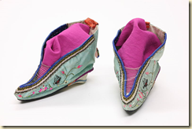
Many people have looked at beautifully decorated silk shoes from China and wondered if they were for a child or a doll. They are surprised to find that these pairs of shoes, some of which are only a little over three inches in length were actually meant to be worn by grown women. But how could a woman get her feet that small? Extremely small feet were achieved through a process known as foot binding.
Foot binding was first practiced in about the 10th century. The process was a lengthy and dangerous one and many girls actually died from having their feet bound. The arch was often broken and the toes folded underneath and bound into place. This was started before a girl’s feet had time to fully form. The average age that girls began the process was anywhere from four to seven years of age. If a girl was lucky, the process would be performed during the winter. Cold weather could numb the feet and help to ease some of the pain.
The process of binding the feet to make them as small as possible would take years to complete. They were unwrapped often and cared for. It was not uncommon for gangrene to set in and for the flesh to rot in some areas. Foot care took place daily in rich families but may have only taken place once or twice a week in families that were less financially well off.
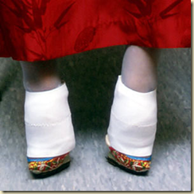
The ideal length for a woman’s foot was three inches long. Women who had longer feet were often considered less desirable and may not have been able to marry as well as women with perfectly bound feet. A woman who had her feet bound could walk on them although it was difficult. In fact, women who were from a higher social class were often more likely to have their feet bound since it showed that the family was affluent enough to afford servants to help the woman and they would not need to walk.
There have been many stories that explained the origin of foot binding. One legend states that Yao-niang, a consort of the ruler Li Yu had performed a dance on feet that had been wrapped in silk cloth. This type of foot wrapping was very similar to the toe shoes that ballet dancers wear today. It became desirable to have feet shaped like a crescent moon.
Foot binding in some form was practiced for approximately 1000 years. Women who were born as late as the 21st century had their feet bound although the practice was outlawed in 1949. Some women who had bound feet did remove their wrappings but this also caused great pain and left the women disabled. There are still women who are living in China today who have the distinctive small feet that were once so prized for a thousand years.

Foot Binding: Primary Sources

Story 1: Su Lian-qi
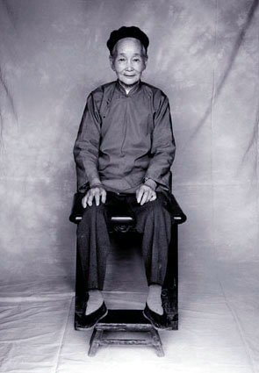
"I had bound feet for many years before liberation in 1949, but when the Communists came to this area they started a movement to stop foot binding. They told us it was very bad for our health and that we should let our feet out, so I did ... slowly.
I was happy when we let our feet out, although it hurt for several months and took a long time to get used to. Once it was done it was so much easier to walk and more convenient all around. As a little girl I remember my mother telling me that foot binding was a tradition and if we didn't do it we'd be very unattractive. I didn't ask why, and I don't know what the purpose of it was other than to be beautiful. I guess it began a few dynasties ago ... we followed it without question.
When I first started binding it was very painful ... so much so that I couldn't sleep at night. I was still able to walk, though. Many girls suffered much more than I did. When I couldn't stand the pain any longer I would secretly loosen the bindings; when my mother found out she wouldn't get angry or scold me. She had bound feet, too, and understood how much it hurt. She would let me keep the bindings loose for a while, but I always had to wrap them up tightly again. I would wash and rebind my feet every day - it had to be done that often because the binding cloth gets caked with blood and pus.
My feet hurt for about one year, but then they were molded into the correct shape and I could walk well. My family did weaving, so I didn’t have to go out and work in the fields. I went out and walked around whenever I wanted to - to play or go buy things in the market. Here women could always go out of the house whenever they pleased.

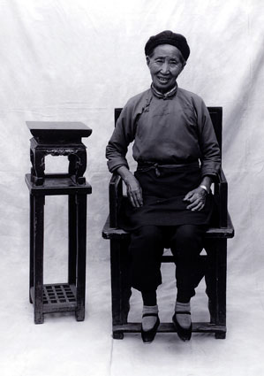
Story 2: Liu Yue-xin

"I've been binding since I was eight or nine years old. I don't bind tightly anymore, so my feet have expanded some compared to how they used to be. I bind now because the bones in my feet are already broken and without the wrappings I'd have no support. I couldn't walk if I didn't bind - besides, I'm used to it - I've been doing it for at least 65 years! It just feels more comfortable this way.
Many younger women let their feet out in the 1940s when the government was encouraging it strongly. They told us it was inconvenient and we shouldn't do it anymore. But if you were in your thirties or older and had been binding for years already, you just couldn't even consider doing it. It would have been even more inconvenient to let them out! Nowadays there is no advantage to having bound feet, but when I was young we did it so we would be beautiful. My mother told me that the smaller one's feet, the better, and that I had to bind so that when I reached marriage age it would be easy to find a husband. People felt that only women with small feet were attractive. But now I think the big feet girls have today are pretty, too.
Many girls used to have a lot of problems when they started to bind. If one's feet are bound badly then it will be very painful and you will have problems with bleeding and pus. This is especially true in the summertime. The pain can really be unbearable when the weather is hot. Mine were bound well and I never had severe problems. Not that it didn’t hurt at all - it DID! It took a good five years before the pain stopped, but I could still work in the house and go out to buy things or go to the market.
If you didn't bind, everyone knew that you were extremely poor. Those girls might still get married, but they would always feel very self-conscious and embarrassed about their feet. They would always have to try to hide them. People felt that natural feet were ugly and a woman could only be beautiful if she had tiny bound feet. Even though there is no advantage to having bound feet now, I don't feel angry about it. I can still get around fine and my feet never cause me any problems. They were useful to me in finding a good husband, but now that's not necessary any more. You don't have to bind your feet now to be beautiful."

