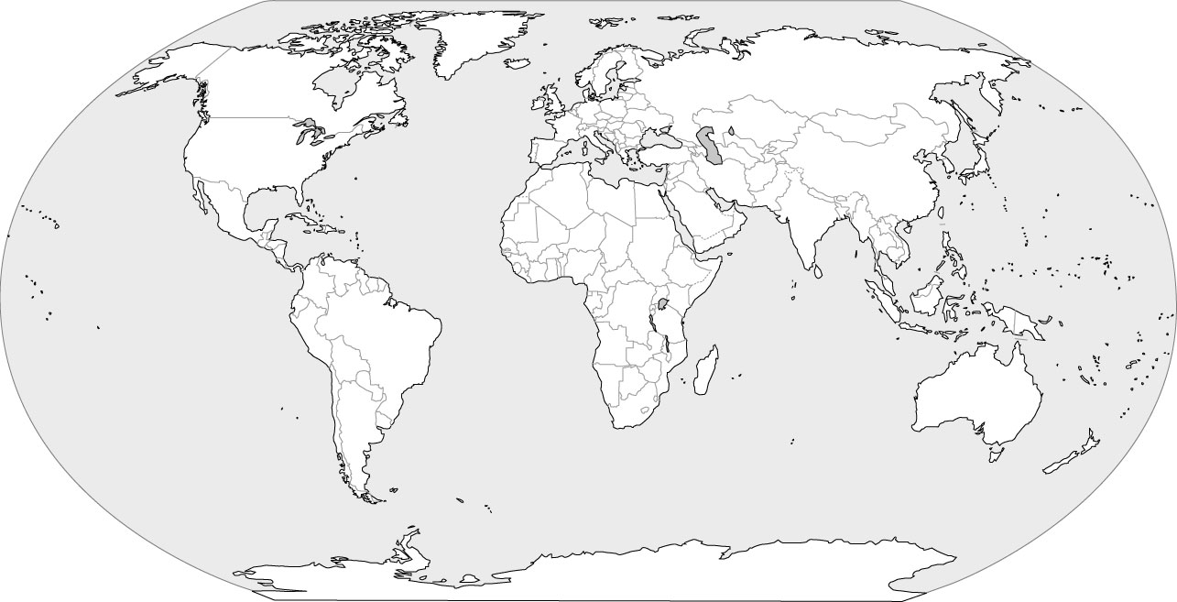
Name: ________________________________________ Date: _____________________
Directions: Label the continents and oceans, and create a compass rose on the back. 50 points

Word Bank:
Africa Atlantic Ocean
Asia Pacific Ocean
North America Indian Ocean
South America Southern Ocean
Australia Arctic Ocean
Antarctica
Europe

2.
1.
E.
B.
C.

D.

4.
5.
6.
3.
7.
WORLD MAP
Draw and label a Compass Rose

Compass Rose Questions:
Directions: Use your compass rose and your world map to answer the following questions. You may wish to draw a second compass rose on the side of the map to help you more easily answer the following questions.
- What is the most southern continent?__________________________________________________________________
- What is the most northern ocean?_____________________________________________________________________
- Which continent is east of Europe? ____________________________________________________________________
- Which ocean is west of North and South America?________________________________________________________
- Which ocean is west of Australia?______________________________________________________________________

