Name_____________________________ Date____________ Unit 4: China and Japan
PACKET B
Total Points: ________
Do Now:
- Copy the objectives from the board:
-Students Will Be Able To:
- Identify the goods and ideas traded on the Silk Road and determine the lasting impact of Silk Road Trade through notes and a primary source reading.

- Image Analysis
Look at the images below and identify what they are, and why they might be important to a civilization.
Image | What is this? | Why is this important?
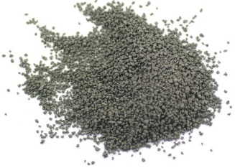
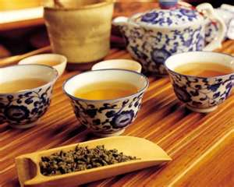

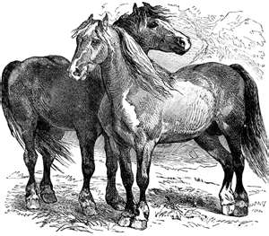

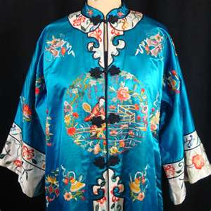

China Notes Part 2
The Tang and Song Dynasty
- The Tang and Song Dynasties restored _______________________ and ____________________ in China
- The Tang dynasty lasted for______________________________________________, between 618 A.D. and 907 A.D.
- Tang rulers created a more ___________________________ by giving land to the peasants and breaking up large pieces of land to reduce the power of their owners.
- The Tang had a highly organized government and employment system called the _________________________________________
- In this system, the government allowed anyone, even commoners, to take an exam. A high enough score on the exam meant a government job.
- Because of this system, the government became filled with highly qualified and intelligent people.
Accomplishments of the Tang and Song Dynasty
- During the Tang and Song Dynasties, the Chinese invented ___________________________ and other items that improved the way they lived and our lives today
  - Compass
  - ___________________________
  - Block Printing/ Moveable Type
- They traded with the West along the Silk Road, a trade Network that connected the East (China) with the West (Europe)
- Many goods and ideas were traded across the Silk Road
From the West (Europe) to the East (China) | From the East (China) to the West (Europe)
- Furs  - Perfumes  - Glass  - Bronze Weapons  - Horses  - Ceramics  - Christianity and Islam | - Tea  - Compass  - Block Printing  - Silk  - Gun Powder  - Paper  - Buddhism

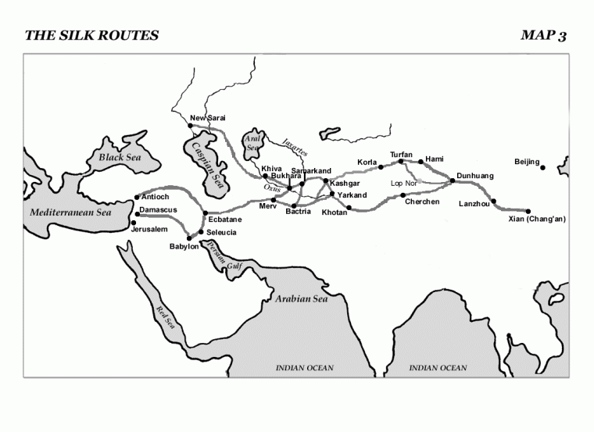

THE MECHANT’S TALE
Nanaivandak, 730-751
I am Nanivandak, a merchant from Samarkand, and a city under the rule of the Bagdad Caliphate (modern day Iraq). I travel for many months from my hometown to Chang'an (in China) to buy and sell goods. Along the route I meet many different people from all over Eurasia. Yet, although we all come from various places, we all speak the language of the Silk Road - Arabic. Ever since I was a young man, I have traveled to Chang'an. I can even remember my first trip with my uncle. We had to take the Northern Silk Road, rather than the Southern. Other merchants and travelers warned us about the Tibetan troops near Kashgar.
The journey itself is dangerous. The mountains though beautiful are full of pit falls and freezing temperatures. As we move closer to the Tarim Basin in China the terrain and climate once again changes. This spring the melting snows caused avalanches and icefalls. The journey is not only hard on us, but also our animals. We need to collect fresh horses and yaks every so often. At times you have to deal with crooked horse traders, and pay more than you need. Soon we will be exchanging our horses for camels. Camels are the only animals that can carry the goods and us across the desert. Yet, they are expensive, and we need to provide for their care on top of paying 14 bolts of silk for each animal. We are held responsible for any injury or death that occurs to our camels. I have seen my uncle willing to sacrifice a man or woman if it meant saving a camel.
My uncle and I whenever possible, travel with other merchants. Safety in numbers is my uncle's motto. When you hear enough horror stories about the lack of water, sudden windstorms and even sandstorms, you really believe in his motto. Occasionally we come across the bones of small groups who broke away or decided to take a less traveled road. The greatest threat is the bandits.
Once a small group of merchants left the caravan early to try to get a head start on business in the town. They never made it. They were ambushed, killed and the goods stolen by bandits. At other times we can see how difficult it is to live along the route with abandoned towns, decaying bodies, human and animal bones. It teaches you to listen and learn survival tactics. We just came across a water well that contained salty water. You couldn't drink it without boiling it. My uncle boiled dough strings in the water that absorbed most of the salt, and made it drinkable.
Yet, the trip is worthwhile if we survive. We take home the profits and more goods to be sold back to our homeland. We brought with us brass, amber and coral to sell in Chang'an. The Chinese officials used the brass for ornaments for the girdles on their official robes, while the Buddhist monks need the brass for their statues. The Persian golden ornaments created by our native Samankands are all the rage in Chang'an. Chang'an is a merchant's paradise. The market place has 3000 stalls representing the 200 merchant guilds in the city. The city is beautiful as will and fruit trees, as well as a beautiful lake surrounding it. Soon with the help of the magnificent one, I will be there in the comfort and beauty of the city
- What is the language of the Silk Road?

- What made the journey so dangerous? List 3 reasons from the text

- Why do merchants go on the trip even if it is dangerous?

- What are some things that were traded along the Silk Road? List 3 items from the text.

Exit Slip
The Tang and Song Dynasties can be compared to Islam’s Golden Age. List THREE inventions that were created in China during the Tang and Song Dynasties and explain each inventions importance.
_______________________________________________________________________________________
_______________________________________________________________________________________
_______________________________________________________________________________________
_______________________________________________________________________________________
_______________________________________________________________________________________
_______________________________________________________________________________________
_______________________________________________________________________________________
_______________________________________________________________________________________
_______________________________________________________________________________________

