Name_____________________________ Date____________ Unit 4: China and Japan
PACKET A
Total Points: ________
Do Now:
- Copy the objectives from the board:
-Students Will Be Able To:
- Evaluate the efforts the Chinese took to keep invaders from attacking China through notes on the Great Wall of China and a reading on the Mongol invader, Genghis Khan

II. Look at the images below and answer the following questions.
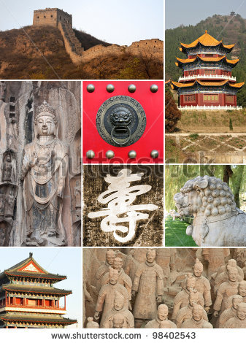
1. Describe what you see in the images. Do you recognize any of the images? From where?

2. Based on the images, what are some things you think we may be discussing in this unit?

3. List as many words, phrases, or images that come to mind when you think of China.

China Notes
Geography of China
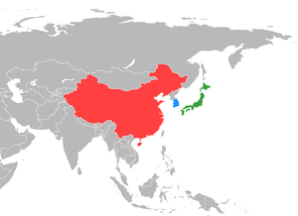
6. ____________________
5. ____________________
4. ____________________
3. ____________________
2. ____________________
1. ____________________

Emperor Qin

- China had a long history of ___________________________________ over land
- There were many groups that wanted to control China
- In 221 BC a new leader _______________________ all of China
- His name was ______________ (pronounced Chin)
- Qin came to power and took the throne at _____________________________________

Qin and the Great Wall
- China shared a ______________________ with the neighboring country of Mongolia
- The Mongolians were _____________________________ and a threat to China’s ____________________
- Qin built the _______________________________ to protect China from invaders to the North
- The wall took ______________________of years to complete
- It is said that thousands of people worked on the wall
- Thousands of these people also died while working on the wall and are now __________________________
- Many other Chinese dynasties (family of powerful leaders) added to the Great Wall of China, expanding its length beyond what Emperor Qin had built
- The wall was meant to keep out _________________________________, as well as small groups of nomads from the North who wished to ____________________________ from small villages.
- It was successful at ___________________________________________ and protected many of China’s small villages.
Total Points: _______
The True Story of Mulan
During the Wei Dynasty (386 CE - 534 CE), there lived a girl in China named Mulan. Mulan's father was a retired general. He had come home sick and frail. He was too old to fight, but not too old to teach Mulan how to ride a horse and use a sword. Girls usually did not learn these skills. But Mulan's father believed everyone should know how to fight, even girls. Mulan became a very skilled fighter.
One day, the government officials sent warriors to Mulan's village. A group from the North, called the Mongols, was coming to fight. War was approaching and men were needed for the Chinese army. Mulan’s father was called to fight, but Mulan knew her father would never survive another battle. Mulan's brother was too young to fight. Only Mulan could take her father's place. But the military did not take girls as replacements for fighting men. This, however, did not stop Mulan.
At the age of eighteen, Mulan decided to join the Chinese army to fight against the Mongolian tribes that wanted to invade China. She told her parents of her plan, bought a horse, and disguised herself as a man. When she reported for duty, she was accepted as a man.
Mulan fought for 12 years and during that time no one ever suspected that she was a girl. When the war was over, the Emperor offered to give Mulan an award and a job. Mulan declined, and instead, returned home to her family. She dressed in women’s clothing again, and went back to her job as a weaver.
Two of the men who had served with Mulan stopped by her village, on their way home. When Mulan came to greet them, they could not believe their eyes. One of them shouted, "You are not Mulan! What have you done with our friend?"
After recounting many memories, they finally believed that Mulan was the person who had fought by their side.
1. Who was China fighting against in the true story of Mulan? _______________________________________

2. Why did Mulan decide she had to fight in her father’s place? ______________________________________ ____________________________________________________________________________________________________________________________________________________________________________________
3. How is the true story of Mulan similar to the Disney movie adaptation? Different? _____________________ ______________________________________________________________________________________________________________________________________________________________________________________________________________________________________________________________________________
4. The Great Wall of China was built to keep the Mongols from entering China. It failed to keep them from attacking during Mulan’s time. After you watch the video answer the following question:
How effective has the Great Wall of China been at protecting China from invaders throughout history?
http://www.history.com/topics/great-wall-of-china/videos/history-of-the-great-wall
______________________________________________________________________________________________________________________________________________________________________________________________________________________________________________________________________________
______________________________________________________________________________________________________________________________________________________________________________________________________________________________________________________________________________
______________________________________________________________________________________________________________________________________________________________________________________________________________________________________________________________________________
_______________________________________________________________________________________________________________________________________
______________________________________________________________________________________________________________________________________________________________________________________________________________________________________________________________________________
______________________________________________________________________________________________________________________________________________________________________________________________________________________________________________________________________________
______________________________________________________________________________________________________________________________________________________________________________________________________________________________________________________________________________
_______________________________________________________________________________________________________________________________________

A Chinese Defeat
Despite the efforts of the Chinese, one Mongol leader was very successful in his attack of China. On your sticky note, jot down 2 facts you learn about the Mongol leader, Genghis Khan from the video. Then, read the article about Genghis Khan, and answer the questions below.
http://www.biography.com/people/genghis-khan-9308634/videos/genghis-khan-mini-biography-2165761046
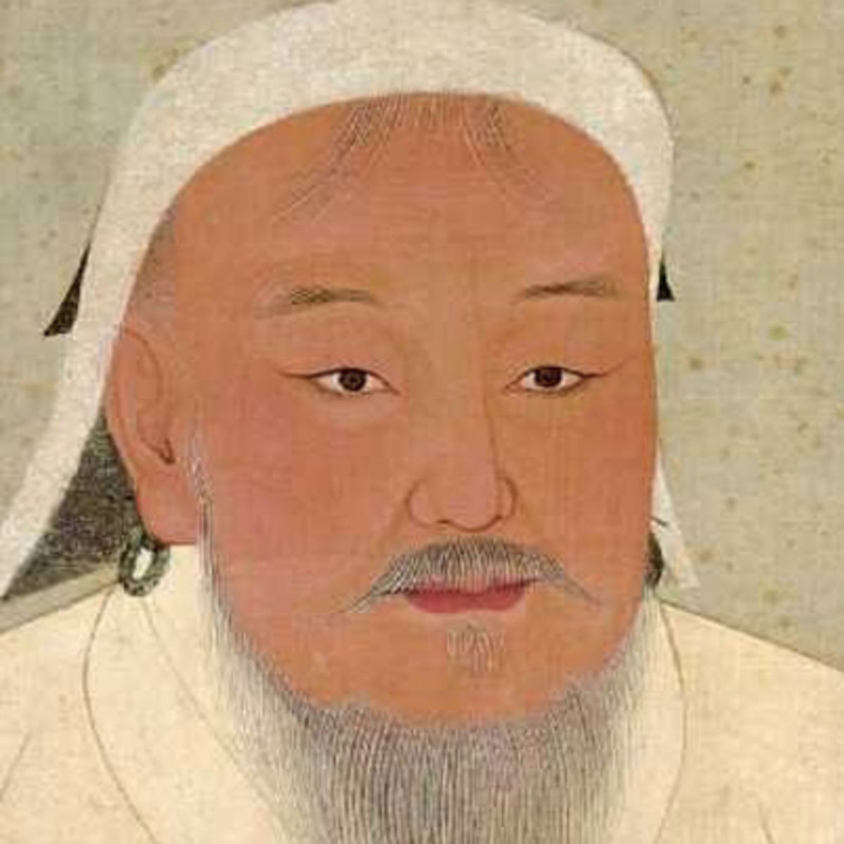
Genghis Khan
Many people think of Genghis Khan as a tyrant and bloodthirsty villain. During his lifetime he killed around 40 million people. However, his accomplishments were nothing short of extraordinary. During his lifetime he conquered more territory than any other leader in history. His successors went on to establish the largest empire that the world had ever seen. No matter how he is viewed, Genghis Khan was a charismatic and dynamic leader whose influence can be felt today throughout Asia and even in parts of Europe.

Early Life
That Genghis Kahn could have earned such prominent place in history is remarkable given that the first three decades of his life were fraught with hardship. Genghis Khan was the son of a Mongol chief. He was born in 1167 and was given the name Temujin which means “iron.” Legend says that when Temujin was born he was clenching a blood clot in his fist. The Mongols believed that symbol meant he was destined to be a great warrior.

Unity among the Mongols
By 1206, Temüjin had managed to unite or subdue several big nomadic tribes and small countries. He united the different Mongol tribes and became known “Genghis Khan,” or the “Universal Leader.” In order to create unity among the Mongols, Ghengis Khan created an official writing script for his empire. He also allowed people in his empire to have some freedom of religion. This encouraged people of various religions, including Muslims, to participate in the rule and benefit of the empire. He relied heavily on intelligence gathering, rapid communication through a system of horse riding messengers, and educated and wise advisers. In order to understand rival empires and to understand how to rule his own empire, he listened to teachers and advisers including religious teachers. He also encouraged the use of technology and weapons of the enemies he encountered, and he integrated foreign technicians into his army. In this way, he was able to conquer large cities. His realized that his army was now big and strong enough to attack the large more civilized empires to the west, south and east.
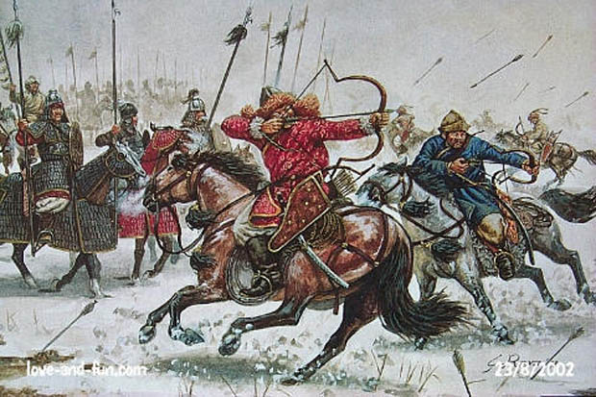
Genghis conquers the Chinese
Genghis Khan was a ruthless warrior. “Life's greatest joy,” Genghis Khan remarked, “is in victory: to conquer one's enemies, to pursue them, to deprive them of their possessions, to make their beloved weep, to ride on their horses and embrace their wives and daughters.” Genghis Khan was a very strong leader, which helped his army take over much of China. Genghis Khan's horsemen were feared throughout China. His army could travel up to 100 miles a day on horseback, while the Chinese traveled by walking. The Mongolian army also used bows and arrows to fight, and were extremely skilled at shooting them on horseback. Genghis Khan also had brilliant military tactics. One tactic was a fake retreat. Genghis Khan and his army would pretend to turn away from the oncoming Chinese army. When the Chinese believed the Mongols were retreating, Genghis would order his army to turn back and fight when his enemies were most weak. When Genghis Khan defeated a group, he murdered the leaders, but invited the warriors of his enemies to join his own army, thus expanding his territory and the size and skill of his army.
After Genghis Khan died, his grandson Kublai Khan continued to take over much of China. Kublai Khan began his own dynasty in China, the Yuan Dynasty and was the leader of much of China for many years.
Total Points: _______
Reading Questions
1. What does the title “Genghis Khan” mean? (2 points)

2. List 3 ways Genghis Khan created unity. (6 points)

3. Which military tactic do you think was most effective and why? (6 points)

(More on next page)
4. Genghis Khan and was an influential person during the Middle Ages. Explain 2 reasons why he was a strong leader. (6 points)

5. The passage begins by saying that “many people think of Genghis Khan as a tyrant and blood thirsty villain.” Do you think this reputation is deserved? Support your answer.

Exit Slip:
Total Points: _______
- Vocabulary Practice: Match the term with its definition

A. Grandson of Kublai Khan, he took over most of China

B. First emperor of China, built the Great Wall of China to protect against the Mongols

C. A sequence of rulers from the same family or group

D. A member of a pastoral people now living chiefly in Mongolia

E. Built to protect the Chinese from invaders of the North, experts believe it is almost 13,000 miles long.

F. The fierce leader of the Mongols who was responsible of the death of over 40 million people.

- _________ Dynasty
- _________ Mongol
- _________ Genghis Khan
- _________ Kublai Khan
- _________ Qin
- _________ Great Wall of China

