Name_____________________________ Date____________ Unit 2: Africa
Total Points: ________
PACKET B
Do Now:
- Copy the objectives from the board:
-Students Will Be Able To:
- Describe the main features of the African ____________________________ kingdoms.

- Vocab Matching
- ______ Savanna A. A large open grassland
- ______ Desertification B. The excess or large amounts of a good
- ______ Surplus C. The process by which usable land turns into desert

- Fill in the blank
Word Bank
Sahara Mt. Kilimanjaro Nile River gold
- ___________________ and salt were important goods that were traded for the African Kingdoms.
- The world’s largest desert is in Northern Africa. It is called the _____________________.
- The _________________ provides the people of Egypt with a much needed source of water in the Sahara Desert.
- Even though many people don’t think about it, there are snow-capped mountains in Africa. _________________________ is an example of one.

Africa Notes Part 2
Total Points: ________
Kingdoms of West Africa
- 3 kingdoms dominated the ______________________ trade during the Middle Ages
- These kingdoms were:
  - Ghana
  - __________________
  - Songhai
The Gold Wealth of Ghana
- This kingdom is locate in what is Southern __________________________ and Western Mali today
- Ghana is first mentioned in texts in _________________________ but is believed to have begun much earlier
- The rulers of the ______________________________ united many farming villages to create the kingdom of _________________________
- Around the 800s, the introduction of the _______________________ as a form of transport changed the kingdom
- Now goods could be traded
- The extensive ___________________________________ of West Africa was sent North to be traded for _____________________________________
- Ghana grew extremely wealthy because of its trade
- Its economy was based mostly on _______________________
- Ghana developed a system to _________________________________________that came through the kingdom
- Ghana was known as __________________________________________________________
- It is said that though the king was a___________________________, he hoarded a lot of his wealth
- It is said that he kept all the ___________________________ and allowed his people only to have gold _____________________
Decline of Ghana
- Due to a____________________________, it’s difficult to know exactly how Ghana began to decline
- Probably occurred around 1076 when they were attacked by _________________________________
- The remains of Ghana became a part of the next major trading kingdom- Mali
The Kingdom of Mali
- After the fall of Ghana, the ________________________________ on the upper Niger suffered a bitter defeat by a rival leader.______________________________________, but one of his sons were executed.
- The only survivor was __________________________________, who by 1235 had crushed his enemies and founded the Kingdom of Mali.
- Mali was an important kingdom from the ________________________________
- Mali is an Arab word that means “where the king dwells.”
- Mali began to control the ______________________________________________
- They had _________________________________________________________within their territory
- It became the world’s leading source of gold
Mali Under Mansa Musa
- The greatest emperor of Mali was__________________________________, who took the throne in 1312
- Mansa-Musa reigned for__________________________________. He worked to ensure peace and order, he expanded _________________________________
- He converted to _______________________and based his system of justice on the Quran.
- In 1324, Mansa Musa fulfilled one of the five pillars of Islam by making the______________________, or pilgrimage to Mecca.
- Through his pilgrimage, he showed his devotion to Islam and developed strong economic and political relations with other Muslim states
- The Hajj made Mali well known and _______________________________
- __________________________ became a leading center of learning
Stop and Think
- Mansa Musa’s pilgrimage helped to spread Islam throughout the region- how do you think the region would have been different if Mansa Musa hadn’t converted to Islam?__________________________________________________________________________________________________________________________________________________________________
Decline of Mali
- Around 1610, an important ruler of Mali died
- It is said that his three sons fought over control of the kingdom
- This broke the kingdom apart

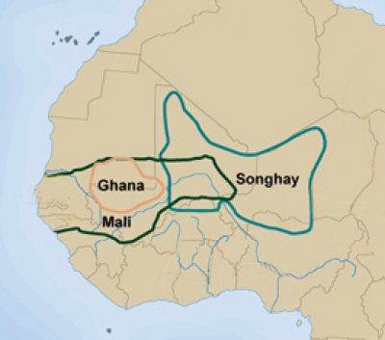

Mansa Musa Primary Source Reading Activity
Total Points: ________
Great kingdoms flourished in West Africa for hundreds of years. However, knowledge of these
kingdoms did not reach a wide audience in the outside world until the 1300's, when Mansa
Musa, the king of Mali made his pilgrimage to Mecca. Soon, people throughout North Africa and
southern Europe were aware of the generous, noble leader from the “land of the gold mines.” In
the excerpt below from The Splendor That Was Africa by Ricky Rosenthal, a modern historian
tells the story of Mansa Musa’s journey to and from Mecca.
Reading Passage | Your comments, questions, and summaries
The markets of Cairo could not be quieted- the least bit of gossip sprints from market booth to market booth. There was no doubt about it, something extraordinary had captured the attention of the great city which served as an important caravan stop. Reports of Mansa Musa’s entrance into Cairo in 1324 was nothing short of spell-binding.  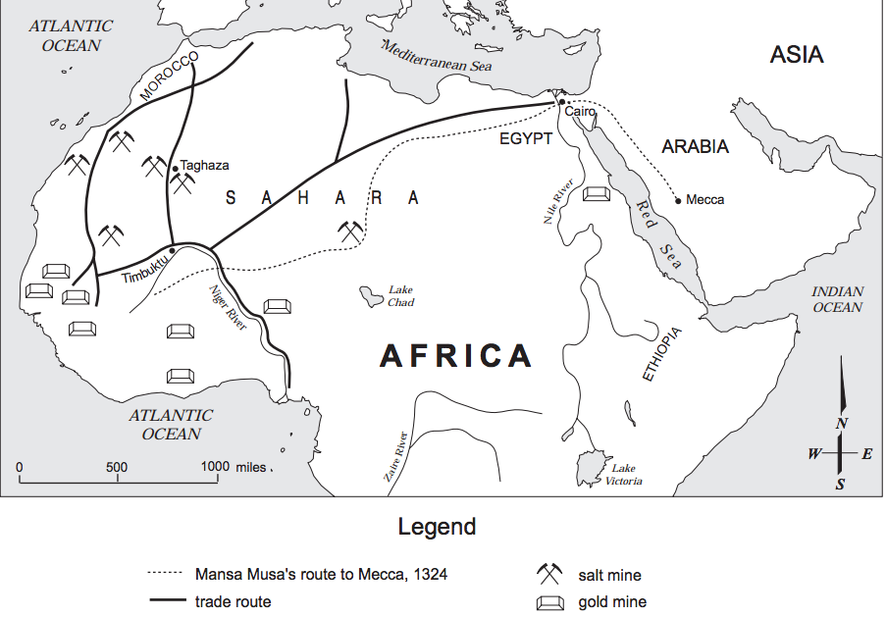  Mansa Musa was on his way to the holy city of Mecca. It was said that when the remarkable sight of his caravan came into view that 60,000 men were counted, including a personal entourage of 12,000 slaves dressed in the most luxurious silks and clothing. 500 slaves carrying a staff of gold weighing about 6 pounds were observed. When the curtain of dust that had enclosed the caravan had finally settled, it was seen that there was a baggage train of 80 camels carrying 300 pounds of gold dust each. Oh, the riches of this extravagant caravan!  Where had Mansa Musa come from was the question of the day. This huge caravan traveled from Nani on the upper Niger to Walata, to Tuat, and then to Cairo. Such a lengthy journey crossed the endless dunes of the Sahara....The very name Sahara, legendary as a temptation to men of all races, is an Arabic word symbolizing wilderness or emptiness, the word having the hot sound of a man gasping for breath. What dangers these travelers had endured on their journey. The terrible dullness of the same sights for day after day- sand dunes and sun for as far as the eye can see! It can start to play tricks on the travelers mind. With the end of the day’s heat you would hope there would be relief for the traveler. But then came the sudden cold of the desert night. But, the nights in the desert have a wonder of their own. Brilliant night skies are filled with stars the likes of which can cause a grown man to cry in their beauty. But the night has dangers of its own, extreme cold and dangerous animals of the desert- Travelers beware of snakes and scorpions that may try to join you for your night’s rest.  This caravan, like many others must have camped gratefully near the spikey desert palm...huddling near the lines of palm trees that offer the only shade in miles....These oases of rest are almost sacred to the traveler. These patches of green plants in the desert are random and hard to find. When the rare, but awesome rain storm falls, water collects in hollows and water-courses and soaks into beds of sand. It is here that the desert plants and trees can live and man can take his much needed rest.  This journey was certainly dangerous yet, Mansa Musa felt such a journey worth it in the performance of his religious duties- The Hajj.  On his return from Mecca, Mansa Musa added people to his traveling party. He returned to Mali with architects, Arab scholars, and government officials. His hajj allowed for new mosques, libraries, and government buildings to be designed in Mali and the city of Timbuktu. People flocked to Timbuktu as a center of learning and the arts. The impact of his hajj forever changed Mali. For the first time, Mali became known around the world for its splendor. | 3.  4.  5.  6.  7.  8.

Exit Slip:
Fill in the following table using your notes.
 | Ghana | Mali
Time Period
Location |  | Southern Mauritania, Western Mali
Source of Wealth
Reason for Decline
Important Kings | Tenkamenin

