Name_____________________________ Date____________ Unit 2: Africa
Total Points: ________
PACKET A
Do Now:
- Copy the objectives from the board:
-Students Will Be Able To:
- Describe the _____________________________ of Africa and evaluate its impact on people throughout history

- Common Perceptions of Africa
- Below are some common myths about Africa, but what do you think? Based on your knowledge and opinions label each statement as True (T) or False (F).
  - Most of Africa is a big jungle. ________
  - Africa is crawling with lions, tigers, elephants, and jaguars. __________
  - Africa is overpopulated and has too many people for its land to support. _________
  - Africa is a country. _________
  - Most Africans live in poverty. __________
  - Africans do not have the modern technology like cell phones and laptops that we have. _______
  - It is always hot in Africa. ____________

- What are your perceptions or opinions about Africa? Fill in the chart below with your mental picture when you think of the follow topics about Africa.
African People and Culture | African Landscapes and Geography | African Issues and Problems

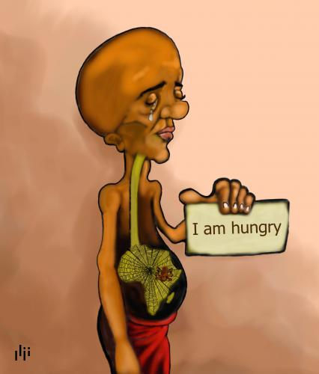
III. World Perceptions of Africa
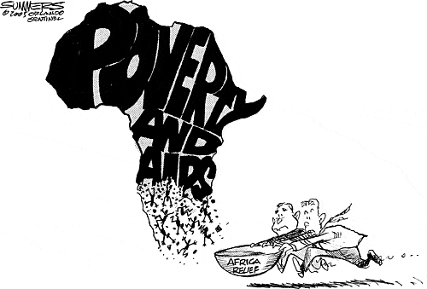
Based on the images to the left, how do you think the world sees Africa?
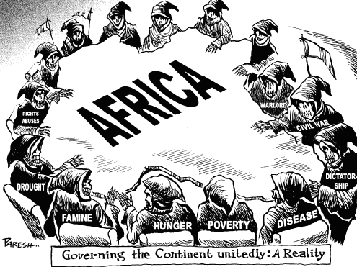

Africa Notes Part 1
Total Points: ________
Geography of Africa
Video clip—as you watch the video clip, write down at least 4 observations of North Africa. What does the land look like? How do the people dress? What is life like in this part of the world?
My observations of South Africa | My observations of North America

View the images on the board and answer the following question:
- Which of the following images do you think is a landscape in Africa? ___________________________________________________________________________
Geography of Africa
- Africa is a land of many landscapes, from lush________________________ , to tropical savannas, to ______________________ that stretch for hundreds of miles
- There is more to the land of Africa than you think!
- Africa is the _________________________________________________________________
- Africa covers __________________ of all the worlds surface
Climate Zones of Africa
- The geography of Africa is __________________________ and has many different types of __________________
- Major Climates of Africa
  - Rainforest
  - ________________________
  - Savanna

Climate Zones of Africa- Savanna
- Africa’s ___________________________________________________ climate zone is the Savanna
- The Savanna is a large ____________________________________ that has good soil which allows people and animals to survive off the land
Climate Zones of Africa- Desert
- The Sahara desert is the______________________________________________ .
- It covers most of __________________________________________________
- The desert made __________________________________________difficult for many years for the people in North Africa
Natural Resources of Africa
- Africa is a land full of ______________________________
- Gold, ________________________ , Iron and ________________________ were all valuable to people
- Later on in Africa’s history, ____________________________________ will become important resources as well
Think, Pair, Share:
- We just learned that Africa is a land of abundant resources, why do you think so many people have the perception that Africa is poor if it has so many valuable resources?
____________________________________________________________________________________
____________________________________________________________________________________
Movement in Africa
- Africa’s geography has affected the way __________________________________ have been able to ____________________________________________________ throughout the continent
- Africa has a long coastline but _____________________________
- Africa has many rivers, but the rivers run through a series of waterfalls that make river ____________________________________________

Think, Pair, Share:
- How would these natural barriers affect the people of Africa?
________________________________________________________________________________________________________________________________________________________________________

- Around 2500, a _______________________________________ slowly dried out the Sahara
- As the land dried out, the desert expanded- This is known as _____________________________
- This caused a lot of land to be lost
- To find________________________ , people migrated, or moved, to new areas

Bantu Migrations
- Over thousands of years, migrations contributed to a rich _________________________ of people and cultures
- This diversity of culture led to many people speaking different languages, but they all came from the _____________________________________________
- As people traveled, they spread their culture

Spread of Islam
- During the Middle Ages, _______________________________ spread Islam into North Africa
- Islam ____________________________ Christianity as the dominate religion of North Africa
- North Africa benefited from the Muslim civilization and culture
  - Mosques
  - ________________________________________
  - Trade Network
- Muslim traders from North Africa spread __________________________ into West Africa

Gold and Salt Trade
- There were two main products that dominated Saharan Trade- ____________________________________________________
- Salt was needed to prevent_______________________________ . Some areas had a lot of salt. Many people even built their homes with salt
- Yet, in other areas, there was not enough salt- which made it a ____________________________ item for trade
- _________________________ was another important commodity, or ______________________, which was abundant in West Africa
- Men dug up the soil, while women washed the soil to___________________________________. The gold dust was then stuffed into feather quills to safely transport it

Think, Pair, Share:
- Which is more valuable in our modern world? Gold or Salt?__________________
- How would our world be different if gold was as valuable as salt and they could be traded equally?________________________________________________________________________________________________________________________________________________________________
Map Instructions
Check off each section after you complete all the directions in that section
KEY: Your key needs to include the following items
Rivers
Lakes
Mountains
Deserts (Color used)
Savanna (Color used)
Section 1: Rivers
Rivers are already drawn on your map- label them:
- Congo River
- Nile River
- Niger River
- Zambezi River

Section 2: Lakes
Label the following lake:
- Lake Victoria

Section 3: Mountains
Label the following mountain- Mountains are shown by a triangle on your map
- Mt. Kilimanjaro
Section 4: Deserts
Color the two desert areas in a light color- Label the following deserts
- Sahara Desert
- Kalahari Desert

Section 5: Savanna
Color the savanna part of your map in a darker color.

Section 6: Oceans
Label the following Oceans
- Indian Ocean
- Atlantic Ocean

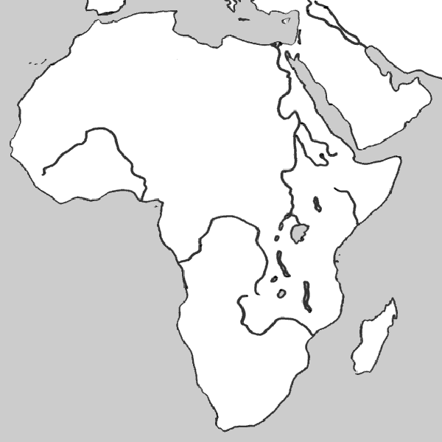
Physical Map of Africa
Total Points: ________

MAP KEY

Exit Slip:
Total Points: _______

- Vocabulary Practice: Match the term with its definition

______1. Savanna
- A good or item that is bought or sold
- The mass movement of the group of Bantu speaking people across Africa
- Excess or large amounts of a good
- The process by which fertile or usable land turns in desert and becomes unusable for farming
- A large grassy land
______2. Desertification
______3. Bantu Migration
______4. Surplus
______5. Commodity

II. Short Answer:
- What are the major climate zones of Africa?
1.
2.
3.
B. What natural resources does Africa have? ________________________________ __________________________________________________________________________________________________________________________________________________________

