Information about Judaism
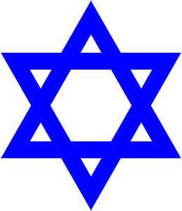
Judaism is the oldest surviving monotheistic religion. Followers of Judaism, called Jews, believe in one God, called Adonai in Hebrew. According to Jewish teachings, Judaism began around 2000 BCE in the Middle East. Abraham is considered to be the first Jew and the first prophet (someone who speaks to God and delivers God’s message). Jews believe Abraham made a covenant (agreement) with Abraham and that Abraham’s descendants would be God’s chosen people. Because Judaism, Christianity, and Islam all recognize Abraham as their first prophet, they are also called the Abrahamic religions.
Jews base their religion on their holy book, called the Torah. It is written in Hebrew, which is considered the sacred language of Judaism. The Torah is the law of God. Jews believe that about 3,000 years ago, God gave the Torah to Moses, Judaism’s most important prophet. In addition to the history of the early Hebrews, the Torah includes 613 commandments (laws) about how to worship God and live a moral life.

The goal of Judaism is to live a good life according to the laws of the Torah and to pass on Jewish traditions to one’s family. One law in the Torah requires Jews to keep the day of Shabbat, or Sabbath, holy. This means that from Friday evening until Saturday evening Jews must rest and pray. Shabbat begins with a traditional meal that includes practices such as breaking challah, or Shabbat bread and sharing wine. On Friday evening and Saturday morning, Jews gather to pray together at a holy building called a synagogue. During the worship service a rabbi, or leader, leads the congregation in prayers and readings from the Torah.

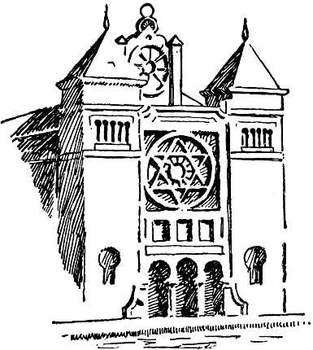
The Torah’s laws direct many aspects of Jewish religion and social life. For instance, the Torah commands all Jews to fast (refrain from eating and drinking) during the holiday of Yom Kippur, the Day of Atonement (being sorry for bad acts). The Torah also calls Jews to give charities to the needy to create justice in the world. The Torah includes the rules of kashrut, which outlines what a Jew can eat. Foods a Jew can eat are called kosher because they meet the Torah’s requirements concerning clean preparation of food. Food that is not kosher is called tref, and includes pork, shellfish, and meat prepared with dairy products. Today, Jews from different sects keep kashrut to varying degrees. The three main sects of Judaism are Orthodox, Conservative, and Reform.

Information about Christianity

Christianity started as an offshoot of Judaism in the first century C.E. Followers of Christianity, called Christians, believe in one God—the God of Abraham, often called Yahweh in English. Christians base their religion on the life and teachings of Jesus of Nazareth, known as Jesus Christ, who was a Jew. During his life, Jesus traveled around northern Palestine teaching about a new covenant between God and the Jews. Those who followed Jesus’s teachings broke away from other Jews and became Christians, worshipping God in a new way that focused on Jesus’s teachings.

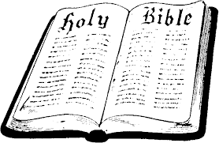
The Christian concept of God is called the Trinity because Christians believe God has three parts: God the Father, God the Son (Jesus Christ), and the Holy Spirit, (God’s presence on earth). Therefore, all Christians believe Jesus was a part of God, and most Christians believe Jesus was both human and divine. Christians believe Jesus died on a cross, was buried, and rose from the dead three days later. Christians also believe Jesus then ascended (went up) to heaven to be with God the Father. The story of Jesus’s life is recorded in the Christian holy book, the Bible, which is made up of two parts, the Old Testament (the Jewish Torah with additions), and the New Testament (written by the followers of Jesus after his death and containing the life story of Jesus and other early Christian writings).
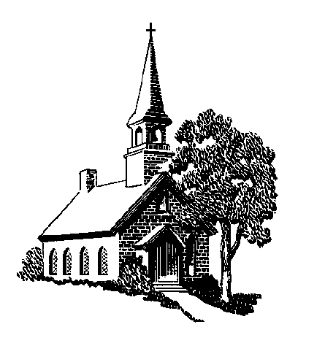
The goal of Christianity is to achieve salvation, which is the eternal life of one’s soul with God in heaven. The opposite is damnation, or eternal suffering in hell. Christians believe one attains salvation by following Jesus’s teachings about living a moral life and by participating in the sacraments—sacred rituals in which Christians experience the Holy Spirit. Though not all sects of Christianity practice all 7 sacraments, all sects recognize baptism and communion. Baptism is the ritual initiation into Christianity and reenacts Jesus’s blessing in the River Jordan. Communion, commonly called the Lord’s Supper, reenacts Jesus’s breaking of bread and sharing of wine at the last dinner before His death.

Ordained ministers—called priests, pastors, or ministers—lead Christians in worship in holy buildings called churches. The most important service occurs on Sunday. During the worship service, Christians experience the sacraments, recite their basic belief, pray, and read from the Bible. Christianity has three main sects, Catholic, Orthodox, and Protestant—all of which believe that God continues to reveal his teachings to the world.

Information about Islam
Followers of Islam, called Muslims believe in one God—the God of Abraham—called Allah in the Arabic language. Muslims believed that God made a covenant (agreement) with Abraham that Abraham and his descendants would be a favored people for their faith and submission to God. Abraham had a son, Isaac, by his wife Sarah, and a son Ishmael, by his wife Hagar. Muslims believe that the Hebrews, or Jews, descended from Isaac and that the Muslims descended from Ishmael.

Islam is based on God’s teachings and on the example of the life of Muhammad. Muhammad was born in Mecca, located on the Arabian Peninsula, around 570 AD. Muslims believe that when he was 40, Muhammad heard a message from God. Muslims learned to accept all the Hebrew prophets (messengers of God), including Moses and Jesus—though they do not believe that Jesus was divine—and that God’s chosen people had not properly followed the prophets. Muslims consider Muhammad to be God’s final prophet. They believe that through Muhammad, God made Mecca the center of Islam and the religion’s holiest city.
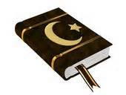
The holy book of Islam is the Qur’an (Koran). Arabic is the sacred language of Islam. Muslims worship in a holy building called a mosque. Friday noon prayers are the most important.
The Qur’an, though distinct from Jewish and Christian texts, contains the revelations God made to Muhammad, which include many of the ideas from the history and law of the ancient Hebrews and their prophets, as well as the story of Jesus’s life. The Qur’an outlines the goal of Islam: living according to God’s guidance, which will be rewarded with salvation, or eternal life in paradise with God. The opposite is damnation, or eternal suffering in hell. To affirm salvation, Muslims must practice five basic tenants known as the “five pillars,” which are found in the Qur’an. The Qur’an also describes hallal, allowed acts, and haram, forbidden acts, which make up a way of life. These includes dietary laws, which do not allow the eating of pork or the drinking of alcohol.

The two major sects of Muslims, Sunni and Shia, share most beliefs, but differ over issues of leadership in the Muslim community.

